The perception that cut flowers are an acceptable way of expressing delight in beauty is sanctioned only insofar as they are not perceived as conspicuously wasteful.

|  |  |
| --- | --- |
| |  | | --- | | Embellished点缀 | |
| |  | | --- | | Elegant优雅 | |
| |  | | --- | | Tasteful有品位 | |
| |  | | --- | | Uncivil不文明的 | |
| |  | | --- | | Wasteful浪费的 | |

切花是一种可以表达美感的可接受方式(perception)，这种看法只有在不被视为明显(conspicuously)浪费的情况下才得到认可(sanctioned)。

Even rigidly(严格的) traditional instructors(讲师) are finding the new method difficult to _______; its implementation reinforces(加强) basics(基础知识) while preparing trainees(受训人员) for more difficult tasks with considerable(大量的 高效的) efficiency.

|  |  |  |  |  |  |  |  |  |  |  |  |
| --- | --- | --- | --- | --- | --- | --- | --- | --- | --- | --- | --- |
| |  | | --- | |  | | |  | | --- | | endorse | | | |  | | --- | | hinder | | | |  | | --- | | fault | | | |  | | --- | | engender | | | |  | | --- | | propose | | |

甚至是严格(rigidly)的传统讲师(instructor)也发现这种新方法难以_______; 它的实施(implementation)加强(reinforces)了基础知识(basics)，同时为受训人员(trainees)准备了效率更高的(considerable)更困难的任务。

|  |  |
| --- | --- |
| |  | | --- | | 赞同endorse | |
| |  | | --- | | 阻碍hinder | |
| |  | | --- | | 故障fault | |
| |  | | --- | | 产生engender | |
| |  | | --- | | 提出propose | |

To the uneducated eye, every lighthouse, despite its distinct location, seems to display irrelevant variations on a homogeneous design.

对于没有受过教育的人(uneducated eye)来说，每座灯塔，尽管其位置不同(distinct)，但在同质设计上似乎都显示出无关紧要的变化。

Astute sailors still value these charts because they know that long after their fragile radios and radar rust into uselessness, the stalwart lighthouses will still be standing tall.

精明的水手们仍然看重这些图表，因为他们知道，在脆弱的(fragile)收音机和雷达生锈(rust)无用之后，坚固(stalwart)的灯塔仍将屹立不倒(standing tall)。

It can be inferred that the author would describe (a sailor incapable of using a lighthouse as a means(手段) of navigation) as

可以推断，作者将无法使用灯塔作为导航手段的水手描述为：

better equipped for adversity than his predecessors

比他的前辈更有能力应对逆境(adversity)

|  |  |  |  |  |  |  |  |  |  |  |  |  |  |  |  |  |  |  |  |  |  |  |  |  |
| --- | --- | --- | --- | --- | --- | --- | --- | --- | --- | --- | --- | --- | --- | --- | --- | --- | --- | --- | --- | --- | --- | --- | --- | --- |
| Though the candidate insisted that his comments were (i) _______, many of his supporters were offended by his attitude, which they considered not only demeaning but also (ii) _______ to their party’s political (iii) _______, and called for him to step down as the party's nominee.   |  |  |  |  |  |  |  |  |  |  |  |  |  |  |  |  |  |  |  |  |  |  |  |  | | --- | --- | --- | --- | --- | --- | --- | --- | --- | --- | --- | --- | --- | --- | --- | --- | --- | --- | --- | --- | --- | --- | --- | --- | | |  | | --- | | **Blank (i)** | | |  | | --- | | newsworthy | | | |  | | --- | | innocuous | | | |  | | --- | | pernicious | | | |  | | --- | | **Blank (ii)** | | |  | | --- | | complementary | | | |  | | --- | | immaterial | | | |  | | --- | | deleterious | | | |  | | --- | | **Blank (iii)** | | |  | | --- | | platform | | | |  | | --- | | stereotype | | | |  | | --- | | label | | | |

尽管候选人坚持认为他的评论是（i）_______，但他的许多支持者都被他的态度冒犯了，他们的态度不仅认为贬低(demeaning)，而且（ii）____________对党的政治观点（iii）_______，并呼吁他采取行动 成为党的提名人。

|  |  |  |  |  |  |  |  |  |  |  |  |  |  |  |  |  |  |  |  |  |  |  |  |
| --- | --- | --- | --- | --- | --- | --- | --- | --- | --- | --- | --- | --- | --- | --- | --- | --- | --- | --- | --- | --- | --- | --- | --- |
| |  | | --- | | **Blank (i)** | | |  | | --- | | 有新闻价值newsworthy | | | |  | | --- | | 无害的innocuous | | | |  | | --- | | 有害pernicious | | | |  | | --- | | **Blank (ii)** | | |  | | --- | | 补充complementary | | | |  | | --- | | 非物质 immaterial | | | |  | | --- | | 有害的deleterious | | | |  | | --- | | **Blank (iii)** | | |  | | --- | | 平台platform | | | |  | | --- | | 刻板印象stereotype | | | |  | | --- | | 标签label | | |

*platform*, which here means the party's statement of its positions.

BCA

|  |  |  |  |  |  |  |  |  |  |  |  |  |  |  |  |  |  |  |  |  |  |  |  |  |
| --- | --- | --- | --- | --- | --- | --- | --- | --- | --- | --- | --- | --- | --- | --- | --- | --- | --- | --- | --- | --- | --- | --- | --- | --- |
| The immense quantity notwithstanding, Carl did not feel (i) _______ by the meal. He persisted with (ii) _______ and whining until the waitstaff (iii) _______ and brought him a second meal.   |  |  |  |  |  |  |  |  |  |  |  |  |  |  |  |  |  |  |  |  |  |  |  |  | | --- | --- | --- | --- | --- | --- | --- | --- | --- | --- | --- | --- | --- | --- | --- | --- | --- | --- | --- | --- | --- | --- | --- | --- | | |  | | --- | | **Blank (i)** | | |  | | --- | | sated | | | |  | | --- | | famished | | | |  | | --- | | perplexed | | | |  | | --- | | **Blank (ii)** | | |  | | --- | | indulging | | | |  | | --- | | abstaining | | | |  | | --- | | carping | | | |  | | --- | | **Blank (iii)** | | |  | | --- | | capitulated | | | |  | | --- | | seethed | | | |  | | --- | | quit | | | |

尽管数量(quantity)巨大(immense)，但卡尔对用餐没有感到（i）_______。 他坚持(persisted)（ii）_______并抱怨(whining)直到服务员（iii）_______并给他第二顿饭。

|  |  |  |  |  |  |  |  |  |  |  |  |  |  |  |  |  |  |  |  |  |  |  |  |
| --- | --- | --- | --- | --- | --- | --- | --- | --- | --- | --- | --- | --- | --- | --- | --- | --- | --- | --- | --- | --- | --- | --- | --- |
| |  | | --- | | **Blank (i)** | | |  | | --- | | 满意的sated | | | |  | | --- | | 迷茫的famished | | | |  | | --- | | 困惑的perplexed | | | |  | | --- | | **Blank (ii)** | | |  | | --- | | 沉迷indulging | | | |  | | --- | | 弃权abstaining | | | |  | | --- | | 吹毛求疵carping | | | |  | | --- | | **Blank (iii)** | | |  | | --- | | 投降capitulated | | | |  | | --- | | 暴怒的seethed | | | |  | | --- | | 放弃quit | | |

Carping (inclined to criticism)

Capitulated (to acquiesce默许的)

ACA

After the trial, the defendant appeared uncharacteristically _______, knowing that she had no choice but to accept the verdict delivered by the judge.

|  |  |
| --- | --- |
|  | convalescent |
|  | oblivious |
|  | apathetic |
|  | acquiescent |
|  | zealous |
|  | compliant |

庭审结束后，被告(defendant)表现出(appeared)一反常态地(uncharacteristically) _______，知道她别无选择，只能接受法官的判决(verdict)。

恢复期(的)convalescent

遗忘的oblivious

无动于衷 apathetic

默许的 acquiescent

热心zealous

顺从的(submissive)compliant

When the Second World War ended, the American economy did not return to the _______ of the 1930s but rather sped up as if driven by an ever-accelerating metronome.

|  |  |  |  |  |  |  |  |  |  |  |  |
| --- | --- | --- | --- | --- | --- | --- | --- | --- | --- | --- | --- |
| |  | | --- | |  | | |  | | --- | | proficiency | | | |  | | --- | | inflation | | | |  | | --- | | malaise | | | |  | | --- | | surfeit | | | |  | | --- | | cynicism | | |

第二次世界大战结束时，美国经济并没有恢复到1930年代的_______，而是像节拍器的不断加速一样加速发展。

proficiency熟练程度

inflation通货膨胀

malaise不适

surfeit过量

cynicism玩世不恭

cynicism 犬儒主义 不信任他人 愤世嫉俗

inflation 通常在经济快速发展时发生，而非经济低迷

|  |  |  |  |  |  |  |  |  |  |  |  |  |
| --- | --- | --- | --- | --- | --- | --- | --- | --- | --- | --- | --- | --- |
| Despite the dogged determination of our leader, who seemed to have every confidence that our perseverance would pay off, I was plagued with _______ about surviving this treacherous journey across the polar ice cap.   |  |  | | --- | --- | |  | omens | |  | delusions | |  | qualms | |  | disquietude | |  | inadequacies | |  | connivances | |

尽管我们的领导者坚决地(dogged)下定决心(determination)，尽管他似乎完全相信我们的毅力(perseverance)会得到回报(pay off)，但我仍然为_______在穿越极地(polar)冰盖(ice cap)的这场险恶(treacherous)旅程中幸存而感到困扰(plagued)。

omens预兆

delusions妄想

qualms忧虑

disquietude不安

connivances不足之处

connivances礼节

选择qualms

///////////

镀锌的galvanized

屈服的succored

陷入困境的beleaguered

坟墓sepulcher

骨头库ossuary

It is clearly _______ that keeps the author's critique from becoming a polemic; if he were less concerned with propriety his article would be worded far less politely.

|  |  |  |  |  |  |  |  |  |  |  |  |
| --- | --- | --- | --- | --- | --- | --- | --- | --- | --- | --- | --- |
| |  | | --- | |  | | |  | | --- | | indulgence | | | |  | | --- | | verisimilitude | | | |  | | --- | | decorum | | | |  | | --- | | reverence | | | |  | | --- | | vulnerability | | |

显然，是________使作者的批评(critique)不再引起争论。 如果他不太关心礼节(propriety)，那么他的文章措辞(worded)就不会那么客气(less politely)。

indulgence放纵

verisimilitude真实性

decorum礼仪

reverence尊敬

vulnerability脆弱性

Those close to the chairperson knew not to take her emotions at face value; they were aware that she was dour when she seemed joyous and _______ when she seemed comfortable.

|  |  |  |  |  |  |  |  |  |  |  |  |
| --- | --- | --- | --- | --- | --- | --- | --- | --- | --- | --- | --- |
| |  | | --- | |  | | |  | | --- | | restive | | | |  | | --- | | nonchalant | | | |  | | --- | | thorough | | | |  | | --- | | dormant | | | |  | | --- | | insouciant | | |

那些与主席(chairperson)关系密切的人知道不要以面子价值来表达她的情感。 他们知道，当她看上去很快乐时，她很疲倦；当她看上去很舒服时，他们_______。

不耐烦，躁动restive

平静的，轻松自在的(having an air of easy unconcern) nonchalant

细致的，彻底的 thorough

休眠 dormant

漫不经心的，轻松自在的(having an air of easy unconcern)insouciant

选择A

Although the novelist attempted a masterful expression of human emotion, his writing was in fact _______; his grandiose demeanor distracted many from a body of work lacking both depth and aesthetic appeal.

|  |  |
| --- | --- |
|  | trenchant |
|  | prosaic |
|  | distinct |
|  | vapid |
|  | unequivocal |
|  | ardent |

尽管这位小说家(novelist)试图很好地表达(masterful)人类情感，但他的写作实际上是_______。 他宏伟的(grandiose)举止(demeanor)分散了(distracted)许多缺乏深度和美学(aesthetic)吸引力(appeal)的作品的注意力。

鞭辟入里 trenchant

平淡无奇的 prosaic (uninterested uncreative)

不同 distinct

空洞的 vapid (uninterested uncreative)

明确的 unequivocal

热心的 ardent

选择Prosaic Vapid

With a (i)_______ of experience to draw upon, Adelaide was more than equal to the job. In fact, her credentials (ii)_______ the qualifications of any other applicant.

|  |  |  |  |  |  |  |  |  |  |  |  |  |  |  |  |
| --- | --- | --- | --- | --- | --- | --- | --- | --- | --- | --- | --- | --- | --- | --- | --- |
| |  | | --- | | **Blank (i)** | | |  | | --- | | preponderance | | | |  | | --- | | dearth | | | |  | | --- | | deficiency | | | |  | | --- | | **Blank (ii)** | | |  | | --- | | followed | | | |  | | --- | | surpassed | | | |  | | --- | | repudiated | | |

凭借（i）________的经验，阿德莱德(Adelaide)不仅仅是工作。 实际上，她的资历(credentials)（ii）_______任何其他申请人的资格(qualifications)。

空白（i）

优势 preponderance

缺乏 dearth

不足 deficiency

空白（ii）

跟着 followed

超过 surpassed

被否决 repudiated

Considering everything Clara had been through, her reaction was quite normal and even (i)_______; I was therefore surprised at the number of (ii)_______ comments and raised eyebrows that her response elicited.

|  |  |  |  |  |  |  |  |  |  |  |  |  |  |  |  |
| --- | --- | --- | --- | --- | --- | --- | --- | --- | --- | --- | --- | --- | --- | --- | --- |
| |  | | --- | | **Blank (i)** | | |  | | --- | | laudable | | | |  | | --- | | inaudible | | | |  | | --- | | histrionic | | | |  | | --- | | **Blank (ii)** | | |  | | --- | | extemporaneous | | | |  | | --- | | conciliatory | | | |  | | --- | | derogatory | | |

考虑到克拉拉经历的一切，她的反应很正常(quite normal)，甚至（i）_______; 因此，我对多条（ii）_______评论的数量感到惊讶，并引起了(elicited)她的回应(response)。

空白（i）

值得称赞的 laudable

听不见 inaudible

过分戏剧化的 histrionic

空白（ii）

即兴的 未准备的 extemporaneous

和解 conciliatory ("placating" or "reconciling(和解)" )

贬低 derogatory (meaning "belittling" or "detracting,")

Yet many find dualism inescapable, including some hard-headed scientists and would-be naturalists who see an intractable problem with the mind, a problem that is simply not amenable(合适的) to molecular explanations.

然而，许多人发现二元论是不可避免(inescapable)的，包括一些头脑笨拙的(hard-headed)科学家和可能成为(would-be)博物学家(naturalists)的人，他们看到了头脑中一个棘手的(intractable)问题，这个问题根本无法通过分子(molecular)解释来解决。

Despite having turned in a (i)_______ skating performance marked by beauty and grace, the gold medalist displayed not (ii)_______ pride but rather profound humility, crediting his coach, team, family, and global fan base with the victory.

|  |  |  |  |  |  |  |  |  |  |  |  |  |  |  |  |
| --- | --- | --- | --- | --- | --- | --- | --- | --- | --- | --- | --- | --- | --- | --- | --- |
| |  | | --- | | **Blank (i)** | | |  | | --- | | maladroit | | | |  | | --- | | supernal | | | |  | | --- | | avaricious | | | |  | | --- | | **Blank (ii)** | | |  | | --- | | wizened | | | |  | | --- | | taciturn | | | |  | | --- | | overweening | | |

尽管获得了以美丽和优雅(grace)为标志的（i）_______滑冰表演，但金牌获得者(gold medalist)并没有表现出（ii）_______的骄傲，而是表现出了极大的谦卑，这归功于他的教练，团队，家庭和全球球迷。

|  |  |  |  |  |  |  |  |  |  |  |  |  |  |  |  |
| --- | --- | --- | --- | --- | --- | --- | --- | --- | --- | --- | --- | --- | --- | --- | --- |
| |  | | --- | | **Blank (i)** | | |  | | --- | | 低效的笨拙的maladroit | | | |  | | --- | | 超常的supernal | | | |  | | --- | | 贪婪的avaricious | | | |  | | --- | | **Blank (ii)** | | |  | | --- | | 干皱的wizened | | | |  | | --- | | 沉默寡言taciturn | | | |  | | --- | | 过度的overweening | | |

选择BC

|  |  |  |  |  |  |  |  |  |  |  |  |  |
| --- | --- | --- | --- | --- | --- | --- | --- | --- | --- | --- | --- | --- |
| Folklore is rarely _______ the time of its origination, as each generation alters the stories, making them more pertinent to the present.   |  |  |  |  |  |  |  |  |  |  |  |  | | --- | --- | --- | --- | --- | --- | --- | --- | --- | --- | --- | --- | | |  | | --- | |  | | |  | | --- | | indicative of | | | |  | | --- | | reminiscent of | | | |  | | --- | | complementary with | | | |  | | --- | | critical to | | | |  | | --- | | judgmental of | | | |

民俗很少起源于_______，因为每一代人都在改变故事，使其与当下更加相关。

|  |  |
| --- | --- |
| |  | | --- | | 指示indicative of | |
| |  | | --- | | 让人联想到reminiscent of | |
| |  | | --- | | 对…互补complementary with | |
| |  | | --- | | 对…重要critical to | |
| |  | | --- | | 对…判断judgmental of | |

选择A

The reclusive author lived in a (i)_______ atmosphere; her house was ornamented with black lace curtains on every window and (ii)_______ antique coffins in place of beds.

|  |  |  |  |  |  |  |  |  |  |  |  |  |  |  |  |  |  |  |  |  |  |
| --- | --- | --- | --- | --- | --- | --- | --- | --- | --- | --- | --- | --- | --- | --- | --- | --- | --- | --- | --- | --- | --- |
| |  | | --- | | **Blank (i)** | | |  |  | | --- | --- | | dilettantish |  | | | |  |  | | --- | --- | | garrulous |  | | | |  |  | | --- | --- | | macabre |  | | | |  | | --- | | **Blank (ii)** | | |  |  | | --- | --- | | ornate |  | | | |  |  | | --- | --- | | amiable |  | | | |  |  | | --- | --- | | innocuous |  | | |

这位隐居的(reclusive)作者生活在（i）_______气氛中； 她的房子在每个窗户上都装饰(ornamented)有黑色蕾丝(lace)窗帘，并且（ii）_______古董(antique)棺材(coffins)代替了床。

|  |  |  |  |  |  |  |  |  |  |  |  |  |  |  |  |  |  |  |  |  |  |
| --- | --- | --- | --- | --- | --- | --- | --- | --- | --- | --- | --- | --- | --- | --- | --- | --- | --- | --- | --- | --- | --- |
| |  | | --- | | **Blank (i)** | | |  |  | | --- | --- | | 贫乏的dilettantish |  | | | |  |  | | --- | --- | | 贫嘴garrulous |  | | | |  |  | | --- | --- | | 骇人听闻的macabre |  | | | |  | | --- | | **Blank (ii)** | | |  |  | | --- | --- | | 华丽的ornate |  | | | |  |  | | --- | --- | | 可亲amiable |  | | | |  |  | | --- | --- | | 无害的innocuous |  | | |

|  |  |  |  |  |  |  |  |  |  |  |  |  |  |  |  |  |  |
| --- | --- | --- | --- | --- | --- | --- | --- | --- | --- | --- | --- | --- | --- | --- | --- | --- | --- |
| Bela, a person with _______ tendencies, eagerly sounds the intentions of others so that he might contravene them.   |  |  |  |  |  |  |  |  |  |  |  |  |  |  |  |  |  | | --- | --- | --- | --- | --- | --- | --- | --- | --- | --- | --- | --- | --- | --- | --- | --- | --- | | |  | | --- | |  | | |  |  | | --- | --- | | consummate |  | | | |  |  | | --- | --- | | contrarian |  | | | |  |  | | --- | --- | | maniacal |  | | | |  |  | | --- | --- | | importunate |  | | | |  |  | | --- | --- | | meritorious |  | | | |

贝拉，一个有________倾向的人，热切地听别人的意图，以便他可以违背他们的意图。

|  |  |  |
| --- | --- | --- |
| |  |  | | --- | --- | | 完善consummate |  | |
| |  |  | | --- | --- | | 逆势contrarian |  | |
| |  |  | | --- | --- | | 疯狂地maniacal |  | |
| |  |  | | --- | --- | | 重要的importunate |  | |
| |  |  | | --- | --- | | 有功的meritorious |  | |

Secluded僻静的

|  |  |  |  |  |  |  |  |  |  |  |  |  |  |  |  |  |  |  |  |  |  |  |
| --- | --- | --- | --- | --- | --- | --- | --- | --- | --- | --- | --- | --- | --- | --- | --- | --- | --- | --- | --- | --- | --- | --- |
| The ordinarily (i)_______ judge acted counter to his reputation when he made the controversial decision to give the convicted defendant the maximum prison sentence. Many believed the judge had been influenced by the prosecutor’s impassioned argument against (ii)_______ for the defendant.   |  |  |  |  |  |  |  |  |  |  |  |  |  |  |  |  |  |  |  |  |  |  | | --- | --- | --- | --- | --- | --- | --- | --- | --- | --- | --- | --- | --- | --- | --- | --- | --- | --- | --- | --- | --- | --- | | |  | | --- | | **Blank (i)** | | |  |  | | --- | --- | | obdurate |  | | | |  |  | | --- | --- | | lenient |  | | | |  |  | | --- | --- | | apathetic |  | | | |  | | --- | | **Blank (ii)** | | |  |  | | --- | --- | | severity |  | | | |  |  | | --- | --- | | clemency |  | | | |  |  | | --- | --- | | impartiality |  | | | |

普通的（i）_______法官在做出有争议的决定时，判处有罪的被告最高刑期，这与他的声誉背道而驰。 许多人认为，检察官对被告人（ii）_______的慷慨激昂的论点影响了法官。

|  |  |  |  |  |  |  |  |  |  |  |  |  |  |  |  |  |  |  |  |  |  |
| --- | --- | --- | --- | --- | --- | --- | --- | --- | --- | --- | --- | --- | --- | --- | --- | --- | --- | --- | --- | --- | --- |
| |  | | --- | | **Blank (i)** | | |  |  | | --- | --- | | 顽固的obdurate |  | | | |  |  | | --- | --- | | 宽容lenient |  | | | |  |  | | --- | --- | | 无动于衷apathetic |  | | | |  | | --- | | **Blank (ii)** | | |  |  | | --- | --- | | 严重性severity |  | | | |  |  | | --- | --- | | 宽大 |  | | | |  |  | | --- | --- | | 公正的impartiality |  | | |

Although technically _______ drug, alcohol is not recommended as a sleep aid because of its negative effects on sleep patterns, particularly when consumed late in the evening.

|  |  |
| --- | --- |
|  | a soporific |
|  | a stimulant |
|  | a somniferous |
|  | a hallucinogenic |
|  | an intoxicant |
|  | an analeptic |

尽管从技术上讲是________药物，但不建议将酒精(alcohol)用作睡眠辅助剂(aid)，因为它会对睡眠方式(patterns)产生负面影响，尤其是在深夜饮用时。

安眠的药物(a soporific)

兴奋剂(a stimulant)

安眠的药物(a somniferous)

致幻剂(a hallucinogenic)

醉人的(an intoxicant)

止痛药(an analeptic)

The members of the writing room have little interest in _______; they find argument far more stimulating.

|  |  |  |  |  |  |  |  |  |  |  |  |
| --- | --- | --- | --- | --- | --- | --- | --- | --- | --- | --- | --- |
| |  | | --- | |  | | |  | | --- | | bickering | | | |  | | --- | | acceding | | | |  | | --- | | dispute | | | |  | | --- | | acuity | | | |  | | --- | | accuracy | | |

写作室的成员对_______没什么兴趣； 他们发现争论更加刺激。

|  |  |
| --- | --- |
| |  | | --- | | 争吵bickering | |
| |  | | --- | | 参加acceding | |
| |  | | --- | | 争议dispute | |
| |  | | --- | | 敏锐度acuity | |
| |  | | --- | | 准确性accuracy | |

选择B

Following discussions between the United States and the United Kingdom after World War II, the General Agreement on Tariffs and Trade (GATT) was founded at the dawn of American postwar economic dominance. The United States agreed to reduce its traditionally high tariffs if the U.K. would relax its trading preference for countries within the Commonwealth. The two countries agreed to include other countries under the GATT charter. The GATT stipulated that members must treat foreign participants in their economies the same as domestic firms and that members would extend to all trading partners concessions awarded to anyone.

The United States generally took the lead in GATT talks, held every few years, by offering generous trade concessions. The growth in world trade and living standards during the first postwar decades seemed to confirm that the system worked. But problems surfaced in the 1960s as foreign-made textiles began to flood U.S. markets. Tensions increased in the 1970s as Japan and other nations expanded their sales of electronic consumer goods to U.S. buyers.

Today, because the United States no longer holds the dominant economic position it did in 1950, its ability to use new GATT negotiations to generate trade growth is limited. But a more fundamental problem is that many countries do not subscribe to U.S. notions of free trade. What happens when one country promotes cartels and another breaks them up, or when one government practices bureaucratic intervention and industrial targeting while another refrains? Such differences underlie present difficulties. Firms from countries with less open economies will penetrate more open markets, but the reverse will not occur. Although such activity will be "fair" under the GATT system, countries with more open economies will resist it, and friction will arise.

In effect, core GATT principles discriminate against societies with open economies. While this has always been true, the problem was initially hidden by US economic dominance and by a greater degree of like-mindedness among a relatively small number of GATT members. As GATT membership has grown and US dominance has waned, this flaw has been a primary source of growing tensions.

在第二次世界大战后美国和英国之间进行讨论之后，关税与贸易总协定（GATT）在美国战后经济占主导地位的曙光下建立。美国同意降低英国传统上的高关税，如果英国放宽对英联邦国家的贸易优惠。两国同意将其他国家纳入关贸总协定的宪章。关贸总协定规定，成员国必须将其经济体中的外国参与者与国内公司一视同仁，并且成员应将授予任何一方的优惠给予所有贸易伙伴。美国通常通过提供慷慨的贸易让步来主导每隔几年举行的关贸总协定的谈判。战后前几十年世界贸易和生活水平的提高似乎证实了该系统的有效性。但随着1960年代外国制造的纺织品开始涌入美国市场，问题浮出水面。 1970年代，随着日本和其他国家/地区扩大了对美国买家的电子消费品销售，紧张局势加剧了。

如今，由于美国不再拥有其在1950年所做的主导经济地位，因此利用新的关贸总协定谈判来促进贸易增长的能力受到限制。但是一个更根本的问题是，许多国家不赞成美国的自由贸易概念。当一个国家提倡合作社而另一个国家瓦解合作社时，或者当一个政府实行官僚主义干预和工业目标制而另一个却拒绝时，会发生什么呢？这种差异是目前的困难。来自经济开放程度较低的国家的公司将渗透更多的开放市场，但不会发生相反的情况。尽管在关贸总协定制度下这种活动将是“公平的”，但经济开放程度更高的国家将抵制它，并会产生摩擦。

实际上，关贸总协定的核心原则歧视了开放经济社会。尽管这一直是正确的，但问题最初是由美国的经济主导地位以及相对较少的关贸总协定成员之间更高程度的志同道合所隐藏。随着关贸总协定成员的增加以及美国的主导地位减弱，这一缺陷已成为紧张局势日益加剧的主要根源。

23点50分 2021年6月30日

新的备考，三战GRE

The four Galilean satellites of Jupiter probably experienced early, **intense bombardment**.

木星的四颗伽利略卫星可能经历了早期的**强烈轰击**。

Thus, the surface of Callisto, the satellite with the oldest surface, **remains scarred by impact(被撞击) craters(陨石坑)**.

因此，拥有最古老表面的卫星卡利斯托的表面**仍然被撞击坑留下了疤痕**。

The younger, more varied surface of Ganymede reveals distinct light and dark areas, the light areas featuring networks of intersecting grooves and ridges凹槽和脊, probably resulting from later ice flows.

木卫三更年轻、更多样化的表面显示出明显的明暗区域，亮区域具有交叉凹槽和山脊的网络，可能是由于后来的冰流造成的。

They showed a landscape dominated by volcanoes, many erupting, making Io the most tectonically active object in the solar system.

他们展示了以火山为主的景观，许多火山喷发，使艾奥成为太阳系中构造(tectonically)最活跃的物体。

The accepted explanation has been that, forced into a highly eccentric orbit by the pull of Jupiter and the other three Galilean moons, Io is engulfed吞没 by tides stemming from a titanic巨大的 contest among the other four bodies.

公认的解释是，木卫一在木星和其他三颗伽利略卫星的拉力下被迫进入一个高度偏心的轨道，被其他四个天体之间一场巨大的竞争所产生的潮汐吞没。

08点57分 2021年7月3日星期六 另一篇阅读总结

Although it is well documented that women face difficulties in reaching senior positions in business, studies indicate that business proprietorship offers one way forward.

尽管有充分证据表明女性在担任商业高级职位方面面临困难，但研究表明，企业独资提供了一种前进的道路。

词汇:

It is well documented that… 有充分证据表面…

Business proprietorship(所有权) 企业独资(做个体户)

Members of ethnic and religious minorities have often started their own businesses as a means of advancement. 少数族裔和宗教少数群体的成员经常创办自己的企业，以此作为进步的手段。

as a means of advancement 以此作为进步的手段

One advantage of ownership is the basence of "organizational selectors"- proprietors need not meet employment criteria based on age, gender, or experience. 所有权的一个优势是“组织选择者”的基础——业主不需要满足基于年龄、性别或经验的就业标准。

Basence 基础

Organizational selector选择者

Question 质疑

fulfill ambitions 实现抱负

central interest 核心利益

designate 指定 划定

Committed to entrepreneurship 致力于创业

好的句型:

Goffee and Scase classify self-employed women into four types by considering commitments to both entrepreneurial and conventional female values.

Goffee 和 Scase 通过考虑对创业和传统女性价值观values的承诺commitments，将自雇女性分为四种类型。

Innovative entrepreneurs question conventional assumptions about the social position of women.

创新企业家质疑(question)关于女性社会地位的传统假设。

Work is a central interest and is much more important than "conventional female roles". 工作是核心利益，比“传统女性角色”重要得多。

In a related category are radicals—proprietors who are active in collective political and economic ventures that promote female issues. 在相关类别中是激进分子——积极参与促进女性问题的集体政治和经济冒险的业主。

Radicals 激进分子

Proprietors 业主，原主，所有者(老板)

Their businesses are accumulated assets are used to further the long-term interests of women.

她们的业务是积累的资产用于促进妇女的长期利益。

further促进

Unlike many innovators, resentment about limited career prospects is rarely a motive for business star-up among conventionals.与许多创新者不同,对有限职业前景的不满很少是传统企业创业的动机。

business star-up 创业

Before staring their businesses, they most were "secondary" workers who moved in and out of the labor market depending upon employment prospects and according to domestic commitments." 他们也“以前不太可能受雇于大型组织。在开始他们的企业之前，大多数是‘二级’工人，他们根据就业前景和国家承诺进出劳动力市场。”

Employment prospects 就业前景

Domestic commitments 国内承诺

Labor market 劳动力市场

Domestics 家庭佣工

Proprietorship offers opportunities for self ‘fulfillment and autonomy(自主) within parameters delineated(划定的) by their other obligations(义务). 个体经营提供了在其他义务所界定的范围内实现自我和自主的机会。

Entrepreneurship is increasingly seen by women as providing access to formerly unavailable economic opportunities. 妇女越来越多地将创业视为获得以前无法获得的经济机会。

Attachment 依恋

Piecemeal 零碎的

Antagonism 对抗 异议

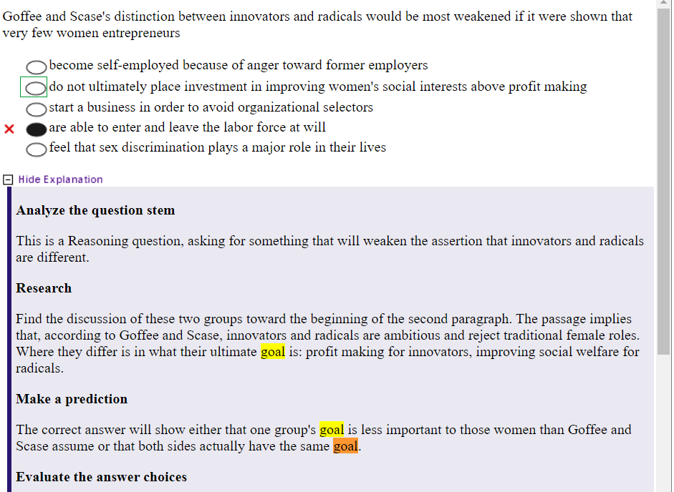

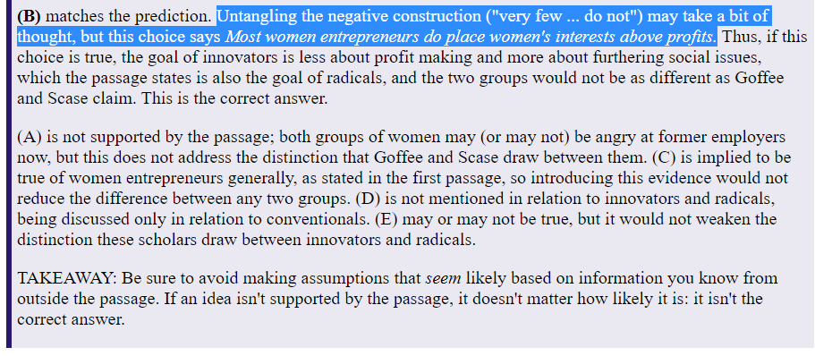

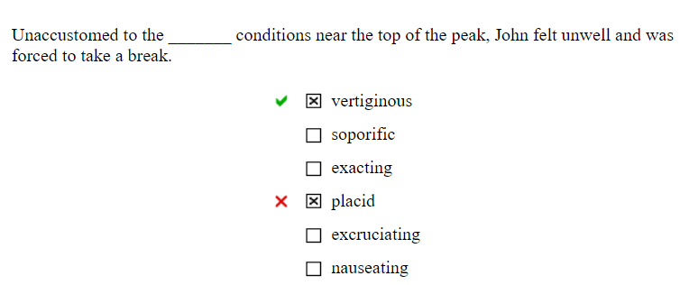

Attachment 依恋

Vertiginous ->dizzying 眩晕的

Soporific ->sleep inducing 催眠的

Exacting->severe 严格的

Placid ->peaceful 平静的

Excruciating -> pain 难以忍受的

Nauseating ->sickening 恶心

选择A F

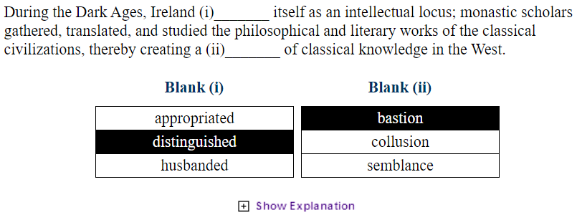

During the Dark Ages, Ireland (i)_______ itself as an intellectual locus; monastic scholars gathered, translated, and studied the philosophical and literary works of the classical civilizations, thereby creating a (ii)_______ of classical knowledge in the West.

|  |  |  |  |  |  |  |  |  |  |  |  |  |  |  |  |
| --- | --- | --- | --- | --- | --- | --- | --- | --- | --- | --- | --- | --- | --- | --- | --- |
| |  | | --- | | **Blank (i)** | | |  | | --- | | Appropriated  Took possession of  占有 挪用 | | | |  | | --- | | Distinguished  Fame because of excellence  闻名遐迩的 杰出的 | | | |  | | --- | | Husbanded  Conserved 保守的 | | | |  | | --- | | **Blank (ii)** | | |  | | --- | | Bastion  Fortification Stronghold  堡垒 据点 | | | |  | | --- | | Collusion  共谋 conspiracy | | | |  | | --- | | semblance  外表 appearance | | |

在黑暗时代，爱尔兰 (i)_______ 本身就是一个知识分子； 僧人收集、翻译和研究古典文明的哲学和文学作品，从而在西方创造了(ii)_______的古典知识。

11点02分 2021年7月17日

Since the composition(成分) of most kidney stones is calcium-based, scientists used to assume that high dietary(饮食的) consumption of calcium would cause an increased occurrence of kidney stones.

由于大多数肾结石的成分是以钙为基础的，因此科学家们过去认为高钙饮食会导致肾结石的发生率增加。

However, in a landmark 1993 study that utilized food consumption questionnaires to measure dietary calcium intake among thousands of adult men over a four-year period, researchers discovered an inverse association between calcium intake and kidney stone occurrence.

然而，在 1993 年一项具有里程碑意义的研究中，研究人员利用食物消费问卷来测量四年期间数千名成年男性的膳食钙摄入量，研究人员发现钙摄入量与肾结石发生之间存在负相关。

The researchers hypothesized that this counterintuitive finding may have been related to presence of oxalate in foods that contain calcium, oxalate and calcium bind to each other, which may facilitate the urinary excretion of both substances without kidney stones forming.

研究人员假设，这个违反直觉的发现可能与含有钙的食物中存在草酸盐有关，草酸盐和钙相互结合，这可能有助于两种物质的尿液排泄，而不会形成肾结石。

A separate 2015 study suggests that these possible benefits of calcium consumption are only present when the ingested calcium is in food.

另一项 2015 年的研究表明，这些钙摄入可能带来的好处只有在摄入的钙存在于食物中时才会出现。

Researchers in that study linked calcium supplements which lack requisite oxalate to bind to calcium to both an increased risk of developing larger, painful kidney stones and the quicker formation of small stones as indicated on CT scans.

该研究中的研究人员将缺乏必要的草酸盐与钙结合的钙补充剂与 CT 扫描显示的更大、更痛的肾结石的风险增加以及小结石更快形成联系起来。

2021年7月19日17点59分

The reclusive author lived in a (i)_______ atmosphere; her house was ornamented with black lace curtains on every window and (ii)_______ antique coffins in place of beds.

[Options](https://www.notion.so/09f1dd58aa164abbbd78f3601b45db1d)

The reclusive(隐居的) author lived in a (i)_______ atmosphere; her house was ornamented(装饰) with black lace curtains on every window and (ii)_______ antique coffins in place of beds.

这位隐居的作家生活在喧嚣的环境中，她的房子每扇窗户都挂着黑色蕾丝窗帘，床前装饰着华丽的古董棺材。

[Options](https://www.notion.so/86974af75d684493bdb20e09065f9d79)

选择macabre可怕的(因为提到了棺材)

选CA

Hannah and Louise appear to refute the hypothesis that the shared genetic code of identical twins creates duplicate personalities. Hannah has never been inclined to stray far from her small farming town in Nebraska, while Louise has a _______ for travel and often derides her sister's provincialism.

Hannah and Louise appear(似乎) to refute(驳斥) the hypothesis that the shared genetic code of identical twins creates duplicate personalities. Hannah has never been inclined to stray far from her small farming town in Nebraska, while Louise has a _______ for travel and often derides her sister's provincialism.

汉娜和路易丝似乎驳斥了同卵双胞胎的共同遗传密码会造成重复人格的假设。汉娜从不倾向于远离她在内布拉斯加州的农业小镇，而路易丝有一个旅行的 xxx，经常嘲笑她姐姐的地方主义。

stray far from(远离)

[Options](https://www.notion.so/95b6316486b44595a4f68b6c3fd0af06)

方框为多项选择 此题选penchant 和 proclivity

10点46分 2021年7月26日

Critics(批评家) have traditionally associated Guy de Maupassant with the irony displayed in his celebrated(著名的) stories. "The Necklace" and "The Piece of String." While Maupassant does indeed indulge(沉浸 放纵) his taste for the unexpected in these two pieces, the "surprise" endings are not meant simply as gimmickry(噱头) to tickle(挑逗) the reader, as has often been asserted(声称 断言), but rather as devices to highlight the injustices of life. In fact, in the bulk of his oeuvre(在他的大部分作品中), Maupassant is more concerned with exploring the vagaries of fate(命运的变幻莫测) than with merely entertaining his public.

In "Miss Harriet," for example, Maupassant's narrator(叙述者 旁白) reminisces(回忆) about an odd woman whose sudden death prompts(驱使 makes) in him feelings of both pity and passion. Yet the death itself, dramatic as it is, does not serve primarily(主要地) to shock(震惊). Instead, Maupassant uses the woman's demise(n.死亡 禅让 让位 薨, v. 让渡 遗赠 ) to underscore(强调) the discrepancy(差异) between appearance and actuality and, more importantly, to emphasize the frequent cruelty of fate.( 相反，莫泊桑用女人的死来强调外表与现实之间的差异，更重要的是强调命运的频繁残酷。) In life, Miss Harriet, the doomed tittle character(这个注定要失败的小角色), seems to the narrator dry(枯燥的) and single-minded(专一的), devoid of any human heat.(没有任何人情味) In death,

(在生活中，哈丽特小姐这个注定要失败的小角色，在叙述者看来是枯燥而专一的，没有任何人情味)

however, Miss Harriet suddenly becomes a "true" woman in the narrator's eyes, a woman whose feelings for the narrator simmered(悄悄酝酿) quietly beneath her reserve. The narrator only then realizes the strength of his own attraction to her, now that it is too late.

批评家传统上将盖伊·德·莫泊桑与其著名故事中的讽刺联系起来。 “项链”和“绳子”。虽然莫泊桑确实在这两部作品中放纵了他对意外的品味，但“出人意料”的结局并不是像人们经常断言的那样简单地逗逗读者的噱头，而是强调生活不公正的手段。事实上，在他的大部分作品中，莫泊桑更多地是在探索命运的变幻莫测，而不是仅仅为了取悦他的公众。

例如，在“哈丽特小姐”中，莫泊桑的叙述者回忆起一个奇怪的女人，她的突然死亡让他感到怜悯和激情。然而，死亡本身，尽管它是戏剧性的，但并不主要用于震惊。相反，莫泊桑用女人的死来强调外表与现实之间的差异，更重要的是强调命运的频繁残酷。在生活中，哈丽特小姐这个注定要失败的小角色，在叙述者看来是枯燥而专一的，没有任何人情味。然而，在死后，哈丽特小姐突然变成了叙述者眼中的“真正的”女人，一个对叙述者的感情在她的保留之下悄悄酝酿的女人。叙述者这时候才意识到自己对她的吸引力有多大，现在已经太晚了。

以后翻译还是一句一句地翻译更好。

Unexpected outcomes can effectively draw attention to the contrast between what is perceived and what is real.

(意想不到的结果可以有效地引起人们对感知与真实之间的对比的关注。)

The use of irony for entertainment is less commendable(可取的) than is its use for social commentary(评论).

(将讽刺用于娱乐不如用于社会评论更值得称道。)

11点28分 2021年7月26日

Having been chastised once for impropriety, the professor — now more cognizant of the sensibilities of her students — tried to refrain from mentioning topics that might be upsetting and used __________ language when those topics could not be avoided.

[]delicate

[]callous

[]prolix

[]verbose

[]euphemistic

[]elucidatory

解析 (方框代表多选)

Having been chastised(惩戒) once for impropriety, the professor — now more cognizant(了解) of the sensibilities(感受力) of her students — tried to refrain(避免) from mentioning topics that might be upsetting and used ________ language when those topics could not be avoided.

这位教授曾因不当行为受到过惩罚，现在更了解她学生的感受力了，她尽量避免提及可能令人不安的话题，并在这些话题无法回避时使用微妙的语言。

Delicate 微妙的 精美的

Callous 冷酷的

Prolix 冗长的

Verbose 冗长的 累赘的 啰嗦的

Euphemistic 委婉的

Elucidatory 说明性的

11点38分 2021年7月26日

As a highly esteemed lecturer in the field of psychology, Dr. Blackmon would be _______ to discuss only the most recent scholarship on the issue of schizoid personality disorder, given her profound understanding of the crucial importance of the historical treatment of the topic.

[]remiss

[]petulant

[]meticulous

[]circumspect

[]orthodox

[]negligent

解析(方框代表多选)

作为心理学领域备受推崇的讲师，布莱克蒙博士将 _______ 只讨论关于精神分裂症人格障碍问题的最新学术成果，因为她对这一主题的历史处理的至关重要性有着深刻的理解。

Remiss 疏忽 懈怠的 粗心的

Petulant 暴躁的 坏心眼的 易怒的

Meticulous 细致 精细的 细密的

Circumspect 慎重的 细心的

Orthodox 正统的 保守的 惯常的

Negligent 疏忽 不在意的 懈怠的

所以选择 Remiss, Negligent

12点00分 2021年7月26日

Although many of the faculty _______ the changes led by the new dean, others were more chary(谨慎) in their acceptance of the radical(激进的) alterations(变革).

[]enjoyed

[]resisted

[]embraced

[]eschewed

[]favored

[]tolerated

尽管许多教职员工_______了新院长领导的变革，但其他教职员工则更加谨慎地(chary)接受这些激进的(radical)变革(alterations)。

[]enjoyed享受

[]resisted反抗

[]embraced拥抱

[]eschewed避开

[]favored偏爱

[]tolerated容忍

选择 embraced, favored

enjoyed, or "took pleasure in," may seem tempting（诱人(去选这个选项)）, but there is no second choice that produces a sentence with a similar meaning.然而第二句是谨慎(chary)，enjoy不是chary 的反义词，后面有更适合的选项。

12点10分

The members of the writing room have little interest in _______; they find argument far more stimulating.

bickering

acceding

dispute

acuity

accuracy

写作室的成员对_______兴趣不大； 他们发现争论更刺激(they find argument far more stimulating)。

bickering争吵

acceding同意 批准 加入 参加 agreeing approving

dispute争议

acuity敏锐度

accuracy准确性

20点54分 2021年7月28日星期三

Social scientists interested in gender differences often refer(参考) to two widely accepted theories of gender identify formation.

对性别差异感兴趣的社会科学家通常参考两种被广泛接受的性别认同形成理论。

Proposed by behaviorist Albert Bandura, social learning theory suggests that children adopt gender identities by observing and modeling others.

行为主义者阿尔伯特·班杜拉 (Albert Bandura) 提出，社会学习理论表明，儿童通过观察和模仿他人来接受性别认同。

Rewards and punishments teach these children what behaviors are appropriate for their given gender. 奖励和惩罚教会这些孩子什么行为适合他们的特定性别。

For instance, a girl who is applauded(称赞) for playing with dolls will continue to engage(从事) in this behavior in the future. 例如，一个因为玩洋娃娃而受到称赞的女孩，以后还会继续从事这种行为。

One the other hand, a boy who is scolded(被骂) for playing with dolls is taught that this behavior is not acceptable for his gender role. 另一方面，一个因玩洋娃娃而受到谴责的男孩被教导这种行为对于他的性别角色是不可接受的。

While this theory is intriguing(有趣), another theory provided a more thorough explanation of individual conceptualizations(概念化) of gender. 虽然这个理论很有趣，但另一种理论对性别的个体概念化提供了更彻底的解释。

Gender schema(图式) theory suggests that men and women develop mental prototypes, or "schemas," of what it means to be "male" or "female."

性别图式理论表明，男人和女人会发展出“男性”或“女性”意味着什么的心理原型或“图式”。

This prototype is socially constructed influenced by, among other things, parents, peers, and media. 这个原型是社会建构的，其中包括父母、同龄人和媒体。

This theory, unlike the broad social learning theory, accounts for more variance(差异) in gender identities; individuals can incorporate into their prototypes traits(特征) and behaviors that they deem(认为) characteristic of their gender. 与广泛的社会学习理论不同，该理论解释了性别身份的更多差异；个人可以将他们认为具有性别特征的特征和行为融入他们的原型中。

Gender schema theory is superior(优越的), as it goes beyond attributing to individuals the simple capacities of observation and reward seeking and instead takes a more complex cognitive perspective. 性别图式理论是优越的，因为它超越了将简单的观察和寻求奖励的能力归因于个人，而是采用了更复杂的认知视角。

23点19分 2021年8月4日星期三

Post-structuralist literary criticism was developed largely in reaction to Ferdinand de Saussure's linguistic theory, which first expressed the relationship between words and the concepts they denote.

后结构主义文学批评的发展主要是对费迪南-德-索绪尔的语言学理论的反应，该理论首次表达了词语和它们所表示的概念之间的关系。

In Saussurian linguistics, an actual word is referred to as a "signifier" --the "sound image" made by the word train, for instance, constitutes a "signifier."

在索绪尔的语言学中，一个实际的词被称为 "符号"--例如，火车这个词所产生的 "声音图像 "就构成了一个 "符号"。

At the same time, the idea evoked by the signifier is termed a "signified."

同时，符号者所唤起的观念被称为 "符号化"。

Saussure argued that the structural relationship between a signifier and a signified constituted a "linguistic sign."

索绪尔认为，符号者和被符号者之间的结构关系构成了一个 "语言符号"。

He saw language as made up entirely of such signs, or structural relationships, and argued that the relationship that constituted these signs was actually arbitrary and based on common usage rather than on some necessary link.

他认为语言完全是由这种符号或结构关系构成的，并认为构成这些符号的关系实际上是任意的，是基于通常的用法而不是基于某种必要的联系。

He did believe, however, that certain ""signifiers"(words) could be permanently linked to specific "signifiers"(concepts) in order to create stable, predictable relationships that evoked constant meanings.

然而，他确实相信，某些""符号"（词）可以与特定的 "符号"（概念）永久地联系起来，以创造稳定的、可预测的关系，唤起恒定的意义。

In contrast to Saussurian linguistics, the post-structuralist view contends that there exists no system of describing ourselves, or of communicating with one another, which does not somehow use our indigenous language systems. To post-structuralists, language defines our identities and is required if we are to maintain those identities.

与Saussurian语言学相反，后结构主义的观点认为，不存在任何描述我们自己的系统，也不存在不以某种方式使用我们本土语言系统的相互交流。对后结构主义者来说，语言定义了我们的身份，如果我们要保持这些身份，就需要语言。

In this view of language, any signifier always signifies another signifier. Definitions and meanings always take the form of metaphors: on term can only be defined as being another term. 在这种语言观中，任何标志物总是标志着另一个标志物。定义和意义总是采取隐喻的形式：一个术语只能被定义为另一个术语。

To change the meaning of a term, on must only change the metaphor through which that term is defined. Meaning shifts from one signifier to another, and because of this, no act of signification is ever fully closed or fully complete.

要改变一个术语的意义，就必须只改变定义该术语的隐喻。意义从一个符号器转移到另一个符号器，正因为如此，没有任何符号行为是完全封闭或完全完成的。

Because the post-structuralists do not view necessary connections as composing permanent linguistic sign relationships, they reject the idea of absolute meaning.

因为后结构主义者不认为必要的联系构成了永久的语言符号关系，所以他们拒绝绝对意义的想法。

Since language constantly shifts along a chain of meaning, "absolute" meanings cannot exist.

由于语言不断地沿着意义链转移，"绝对 "的意义不可能存在。

Language in this view can never be viewed as entirely stable.

在这种观点中，语言永远不可能被看作是完全稳定的。

Whereas Saussure believed that linguistic sign relationships could create stable, consistent meanings between terms and the images they evoke, post-structuralists argue that meaning can be established only through discourse. Thus, meaning is never absolute, immutable, or concrete, because it is always dependent upon the differing and constantly shifting discourse in which language terms operate.

索绪尔认为语言符号关系可以在术语和它们所唤起的图像之间创造稳定的、一致的意义，而后结构主义者则认为，意义只能通过话语建立。因此，意义从来都不是绝对的、不变的或具体的，因为它总是依赖于语言术语所运作的不同的、不断变化的话语。

In addressing a class, a professor describes the mind first as a blank slate to be written on and later as a garden to be cultivated. In light of the information in the passage, the professor’s lecture would best represent:

一位教授在课堂上讲话时，先是将头脑描述为一块待写的白板，后来又描述为一个待耕耘的花园。根据这段话中的信息，该教授的演讲最能代表:

2021年8月5日

In an effort to simultaneously pander to opposing demographics, the politician's speeches became _______, repeating inoffensive and unoriginal slogans.

|  |  |
| --- | --- |
|  | banal |
|  | truncated |
|  | blithe |
|  | trite |
|  | poignant |
|  | trenchant |

为了(In an effort to)同时迎合(pander)对立(opposing)的人口群体(demographics)，政治家(politician)的演讲变得_______，重复着无伤大雅(inoffensive)、毫无创意(unoriginal)的口号。

平庸的banal

截断的，削短的，简短的truncated

平淡的blithe

陈腐的trite

凄美的，深深的影响 poignant

尖锐的trenchant

选择banal, trite(blithe平淡的 非同义词，不选之)

underscore how baffling outbreak of 1918 is

强调(Underscore)1918年的爆发(outbreak)是多么的令人费解(baffling)

A good picture of the structure of this flu strain(菌株)

这种流感菌株结构的良好图片

Extol(歌颂) the progress science has made in tracing the origins of the 1918-1919 pandemic

Sasha was perturbed when her classmates began emulating her clothing style; her ______ was part and parcel of her identity.

immutability

incorruptibility

singularity

heterodoxy

homogeneity

fashion

当她的同学开始模仿她的服装风格时，萨沙感到很不安(perturbed)；她的______是她身份的一部分和组成部分。

不变性immutability

廉洁性incorruptibility

单一性 singularity

异质性heterodoxy

同质性homogeneity

时尚 fashion

选择 heterodoxy, singularity

Typically, affection is a (i)_______ for people, but it can be (ii)_______ to physicians, who must be dispassionate in order to properly treat their patients and who therefore often decline to treat their own family members.

Blank (i)

gratifying emotion

disquieting event 令人不安的事件

standard concession

Blank (ii)

a liability 负债 责任 drawback disadvantage

a catalyst 催化剂

an anachronism(不合时宜)

选择AA

The miners found the mule perfectly (i)_______ when descending through the galleries, but upon returning to the face, it became (ii)_______ to the point where two men could not shift it.

Blank (i)

tractable

affable

inscrutable

Blank (ii)

amenable

recalcitrant

intrusive

矿工们发现这头骡子(mule)在通过巷道(galleries)下降时完全(i)_______，但回到工作面后，它变得(ii)_______，以至于两个人都无法转移它。

空白(i)

驯服的 tractable

和蔼可亲 affable

高深莫测 inscrutable

空白(二)

和蔼可亲 amenable

顽固的 recalcitrant

烦人的 intrusive

选择 tractable, recalcitrant

Bone depletion—a decrease in the thickness, density, and strength of bones—tends to occur as humans age. The bones of some individuals seem to become thicker, denser, and stronger with regular weight-bearing exercise, such as weight lifting, and with the intake of dietary calcium.

Which of the following can be correctly inferred from the statements above?

Individuals who eat sufficient calcium run no risk of bone depletion in old age.

Individuals who do not undertake weight-bearing exercise have a high risk of experiencing bone depletion late in life.

Weight lifting and intake of dietary calcium are the most effective methods of avoiding bone depletion.

A program of regular weight-bearing exercise and intake of dietary calcium allows some individuals to avoid one of the deleterious effects of aging.

Only weight-bearing exercise is necessary to build bone thickness, density, and strength.

骨骼耗损--骨骼的厚度、密度和强度的下降--往往随着人类的年龄增长而发生。一些人的骨骼似乎在经常性的负重运动（如举重）和摄入食物中的钙后会变得更厚、更密、更强。

从上面的陈述中可以正确推断出以下哪项？

摄入足够钙质的人在年老时没有骨质流失的风险。

不进行负重运动的人在晚年有很高的骨质流失风险。

举重和摄入食物中的钙是避免骨质流失的最有效方法。

定期进行负重运动和摄入膳食钙的计划使一些人能够避免衰老的有害(deleterious)影响之一。

只有负重运动才是建立骨骼厚度、密度和强度的必要条件。

选择D

In Edgar Allan Poe's "The Cask of Amontillado," the vengeful Montresor ____ his friend Fortunato by sealing him up inside a wall.

quaffs

preserves

taunts

condones

immures

在埃德加-爱伦-坡的《阿蒙提拉多的酒桶》中，复仇的(vengeful)蒙特雷索尔把他的朋友福图纳托____在一堵墙里，使他无法动弹。

饮酒 quaffs

保存 preserves

嘲弄 taunts

纵容 condones

监禁 immures

Air travel is becoming increasingly more dangerous. In the last year there have been seven major collisions resulting in over 700 deaths, more deaths than in any previous year.

Which statement, if true, would most weaken the argument above?

Since the volume of air traffic has been increasing all the time, an increase in the number of deaths due to collisions does not necessarily mean greater danger.

The increase in collisions can be explained by statistical coincidence, hijackings, and unusual weather.

Mortality per passenger mile is lower for air travel than for any kind of surface transportation.

The increase in deaths due to collision in air travel has proceeded at a rate identical to that for deaths in all other major forms of transportation.

Last year the average number of passengers per flown plane was significantly lower than that of previous years.

航空旅行正变得越来越危险。在过去的一年里，有七起重大碰撞事故，造成700多人死亡，比以往任何一年的死亡人数都多。

哪句话如果是真的，会最能削弱上面的论点？

由于空中交通量一直在增加，因碰撞而死亡的人数增加并不一定意味着更危险。

碰撞的增加可以用统计上的巧合、劫持和异常天气来解释。

航空旅行的每乘客英里死亡率低于任何一种地面运输。

航空旅行中因碰撞造成的死亡人数的增加速度与所有其他主要运输方式的死亡人数的增加速度相同。

去年，每架飞行的飞机的平均乘客数量明显低于前几年。

选择A

Those close to the chairperson knew not to take her emotions at face value; they were aware that she was dour when she seemed joyous and _______ when she seemed comfortable.

restive

nonchalant

thorough

dormant

insouciant

那些与主席关系密切的人知道不要轻信她的情绪；他们知道，她在看起来很高兴的时候却很沉闷，在看起来很舒服的时候却_______。

躁动

不苟言笑

彻底

休眠的

不苟言笑

选择 restive

The cause of the peculiar columnar growth pattern displayed by junipers growing near burning underground veins of lignite coal has never been convincingly explained. Until recently, the accepted theory posited that the abundance of carbon monoxide in the local atmosphere caused the columnar growth. However, a new theory holds that the cause is the persistent heat present near these underground fires which, while not intense enough to inflame the trees, can nonetheless change their normal growth pattern.

The existence of which of the following would provide the strongest support for the new theory?

A columnar juniper growing in an atmosphere of intense heat and an absence of carbon monoxide

A normal juniper growing in an atmosphere of intense heat and an absence of carbon monoxide

A columnar juniper growing in an atmosphere of normal heat and a high concentration of carbon monoxide

A normal juniper growing in an atmosphere of intense heat and a high concentration of carbon monoxide

A columnar juniper growing in an atmosphere of intense heat and a high concentration of carbon monoxide

生长在燃烧的地下褐煤矿脉附近的杜松(juniper)所表现出的特殊的柱状生长模式，其原因从未得到令人信服的解释。直到最近，公认的理论认为，当地大气中丰富的一氧化碳导致了柱状生长。然而，一种新的理论认为，其原因是这些地下火附近存在的持续的热量，虽然其强度不足以使树木发炎，但仍能改变其正常的生长模式。

以下哪项的存在将为新理论提供最有力的支持？

生长在高热和没有一氧化碳(Carbon monoxide)的大气中的柱状杜松

生长在高热和没有一氧化碳的环境中的普通刺柏

生长在正常热量和高浓度一氧化碳环境中的柱状杜松

生长在高温和高浓度一氧化碳环境中的普通杜松

生长在高温和高浓度一氧化碳环境中的柱状杜松

选择A

Many conditions that affect the liver are signaled by ______ skin, which turns a sickly yellow due to increased levels of bilirubin in the blood.

sallow

rubicund

jaundiced

flushed

ruddy

bronzed

许多影响肝脏的疾病都以___的皮肤为信号，由于血液中的胆红素水平增加，皮肤会变成病态的黄色。

焦黄 黧黑 sallow

红斑 红宝石 rubicund

黄疸 jaundiced

脸色红润 flushed

红润 ruddy

古铜色 bronzed

选择 sallow jaundiced

The apartment was furnished in a rather _______ style; in fact, "furnished" might be too strong a word, since the only object available to sit on was a straw mat in the middle of the room. (方框代表多选)

[]disingenuous

[]iconoclastic

[]contemptible

[]ascetic

[]macabre

[]austere

该公寓的装修风格相当_______；事实上，"装修 "这个词可能太强烈了，因为唯一可以坐的物体是房间中间的一张草(straw)席(mat)。

虚情假意 disingenuous

讽刺性的 iconoclastic

可鄙的 contemptible

禁欲主义者 ascetic

诡异 macabre

朴素的 austere

选择 ascetic, austere

Facing far larger crowds than anticipated, the event staff reneged on their agreement with the original locale and moved the concert to a more _______ venue.

commodious

austere

grandiloquent

sanctioned

egregious

面对远远超过预期的人群，活动工作人员违背了与原地点的协议，将音乐会移到了一个更_______的场地。

commodious商品 便利 大方 宽敞的

austere 朴素的

grandiloquent 夸夸其谈

sanctioned v.制裁的v.拥护 n.法令

egregious 恶劣的 过分的

选择 commodious

In an attempt to encourage residents to recycle glass, aluminum, and paper waste, the mayor of Townsville plans to establish specially designated drop-off centers to which residents can bring these materials for recycling. The mayor argues that the increased recycling will significantly reduce the town's ecological impact on natural resources.

Which of the following, if true, indicates that the plan to establish specially designated recycling centers **will not** have the **effect** that the mayor intends?

The delivery of the materials from the drop-off centers to the appropriate recycling plants will involve considerable expense for the town.

In order to occupy unused city-owned property, the drop-off(投放) centers will be such a great distance from the town's population centers as to discourage use.

Similar centers established in other towns have been ineffective in reducing the amount of waste produced by the towns.

Recent technological advances have provided many new uses for recycled aluminum and glass.

Many of the proposed centers will be open only at those times calculated to be the most popular with town residents.

为了鼓励居民回收玻璃、铝和纸张垃圾，汤斯维尔市市长计划建立特别指定的投放中心，居民可以将这些材料带到这里进行回收。市长认为，增加回收将大大减少该镇对自然资源的生态影响。

以下哪项，如果是真的，表明建立特别指定的回收中心的计划不会产生市长所期望的效果？

将材料从投放中心运送到适当的回收工厂，将给该镇带来相当大的开支。

为了占用未使用的城市财产，投放中心将与该镇的人口中心相距甚远，以至于无法使用。

在其他城镇建立的类似中心在减少城镇产生的废物量方面是无效的。

最近的技术进步已经为回收的铝和玻璃提供了许多新的用途。

许多建议的中心将只在计算出的最受城镇居民欢迎的时间开放。

选择 B In order to occupy unused city-owned property, the drop-off centers will be such a great distance from the town's population centers as to discourage use.

The audience member claimed not to have been affronted (i)_______ by the comedian's inappropriate remarks, but her ramrod posture and (ii)_______ glowering eyes, captured on multiple cameras, hinted at her barely suppressed displeasure.

Blank (i)

charmed

affronted

castigated

Blank (ii)

glowering

demure

sentimental

这位观众声称没有被喜剧演员的不当言论 (i)_______，但她的粗壮姿势和(ii)_______的眼睛，被多台摄像机拍到，暗示她勉强压抑的不悦情绪。

空白 (i)

迷人的

被冒犯的

被指责

空白(二)

怒目而视

端庄

多愁善感

选择affronted glowering

Ryan is paralyzed by his own ________: he imagines having elaborate conversations with various people, but he fails to engage in discourse with them when opportunities to do so arise.

diffidence

sycophancy

asphyxiation

convalescence

rectitude

瑞安被自己的_____所麻痹：他想象着与不同的人进行精心的对话，但当出现机会时，他却无法与他们进行对话。

害羞 不自信 diffidence

拍马屁 谄媚 sycophancy

窒息 asphyxiation

疗养 convalescence

正确性 rectitude

"Blog" is just one of the many (i)_______ that have emerged as computers have become (ii)_______ fixtures of daily life. There are, of course, (iii)_______ linguists who refuse to accept these computer-related terms, even though these same linguists rely just as much on computers as the rest of the population.

Blank (i)

Publications Neologisms Advances

Blank (ii)

Inchoate indispensable temporary

Blank (iii)

Obstinate well-educated experienced

Neologisms 新词

Inchoate 初始化的

Indispensable 不可或缺的

Obstinate 顽固的

选择 BBA

The journal's reviews expose the critics' incompetence(无能) more than that of the author, as most of the reviews provide no constructive criticism and amount to nothing more than tiresome(烦人的) and insulting _______ aimed at deflating the author's ego.

Articulations

invectives

elocutions

surmises

diatribes

speculations

该杂志的评论比作者更暴露了批评家的无能，因为大多数评论没有提供任何建设性的批评，只是令人厌烦和侮辱性的_______，目的是打消作者的自负。

阐述 articulation

谩骂 invectives

雄辩 演说elocutions

谩骂 diatribes

抨击 猜测speculations

猜测 选择BE

Aria had successfully navigated complex literary tomes that would have intimidated some scholars, yet she had difficulty following the incoherent plot of this particular book, as, in her opinion, it was far too _______ to be readable.

monotonous

fallacious

chaotic

disjointed

erroneous

complicated

阿丽雅曾成功地浏览过复杂的文学巨著，这些巨著会让一些学者望而生畏，但她却很难跟上这本书不连贯的情节，因为在她看来，这本书太过_______，无法阅读。

单调乏味

谬误

混乱的

不连贯

错误的

复杂

选择 Chaotic, disjointed

While modern works of philosophy are generally oriented toward a small audience of experts in the field, resulting in a profusion(丰富，大量) of _______ texts, some philosophers have made concerted(齐心协力的) efforts to write in a way that is understandable to a layperson(外行).

recondite

protracted

pellucid

abstruse

reviled

licentious

虽然现代的哲学作品一般都是面向该领域的一小部分专家读者，导致大量的_______，但一些哲学家还是做出了一致的努力，以非专业人士可以理解的方式来写作。

复杂的

冗长的

明确的

深奥的

谩骂

淫荡的

选择 recondite abstruse

Commercial entrepreneurs sometimes become celebrities, with their names known globally for the new ideas, processes, and products they have brought to market. Less well known-but with as great an impact- are social entrepreneurs. The desire of social entrepreneurs is to change society in some way. For example, John Muir, the founder of the Sierra Club, had a major impact on the way Americans view the natural environment. Today's social entrepreneurs bring energy and novel approaches to issues around the world, tackling(对付) seemingly intractable problems such as inadequate water supplies in rural communities, lack of vaccination against childhood diseases in developing nations, and the basence(基础) of hospitals in areas that badly need them. To succeed, social entrepreneurs need more than energy and ideas. They must also marshal(元帅 统帅) charisma(魅力) and conviction(定罪) to persuade many people that changes are necessary, timely, and possible. This fact may explain why some social entrepreneurs start out as celebrities rather than becoming celebrates; their fame gives them an international platform from which to pitch their plans. In fact, among the best-known social entrepreneurs today are people who gained celebrity for their achievements as commercial entrepreneurs.

Which of the following situations would the author likely consider most similar to the transition from celebrity commercial entrepreneur to social entrepreneur?

A homeowner plants trees by the house's western exposure to reduce next summer's air-condition costs.

A guitarist applies her skills to learning to play banjo and electric bass.

A college tutor reinforces his students' understanding of algebra to prepare them for a calculus course.

A pastor encourages her congregation from the pulpit to commit to a voter registration project.

A well-known actor weighs whether to run for public office.

商业企业家有时会成为名人，他们的名字因其带来的新想法、工艺和产品而闻名全球。社会企业家则鲜为人知，但其影响同样巨大。社会企业家的愿望是以某种方式改变社会。例如，塞拉俱乐部的创始人约翰-穆尔对美国人看待自然环境的方式产生了重大影响。今天的社会企业家为世界各地的问题带来了活力和新颖的方法，解决了一些看似棘手的问题，如农村社区供水不足，发展中国家缺乏儿童疾病的疫苗接种，以及急需医院的地区缺乏医院。为了成功，社会企业家需要的不仅仅是精力和想法。他们还必须调集魅力和信念来说服许多人，使他们相信变革是必要的、及时的和可能的。这一事实可能解释了为什么一些社会企业家开始时是名人，而不是成为名人；他们的名气给了他们一个国际平台，让他们在那里推销他们的计划。事实上，在当今最知名的社会企业家中，有一些人是因为作为商业企业家的成就而获得名声的。

作者认为以下哪种情况最类似于从知名商业企业家到社会企业家的转变？

一个房主在房子的西边种树，以减少明年夏天的空调费用。

一位吉他手将她的技能用于学习弹奏班卓琴和电贝司。

一位大学导师加强了他的学生对代数的理解，为他们的微积分课程做准备。

一位牧师在讲坛上鼓励她的会众致力于一个选民登记项目。

一位知名演员在权衡是否要竞选公职。

选择牧师的那个。

Q

After the trial, the defendant appeared uncharacteristically _______, knowing that she had no choice but to accept the verdict delivered by the judge.

convalescent

oblivious

apathetic

acquiescent

zealous

compliant

审判结束后，被告一反常态地出现在_______，她知道自己别无选择，只能接受法官作出的判决。

疗养

漠不关心

麻木不仁

默许的

热心的

顺从

选择 compliant acquiescent

|  |  |  |  |  |  |  |  |  |  |  |  |  |
| --- | --- | --- | --- | --- | --- | --- | --- | --- | --- | --- | --- | --- |
| Katie was known for her lively behavior and excitable moods, but the illness left her bedridden for months; when she at last began to convalesce(康复), it was a great relief to see her _______ spirit return.   |  |  |  |  |  |  |  |  |  |  |  |  | | --- | --- | --- | --- | --- | --- | --- | --- | --- | --- | --- | --- | | |  | | --- | |  | | |  | | --- | | vivacious | | | |  | | --- | | provocative | | | |  | | --- | | pensive | | | |  | | --- | | restless | | | |  | | --- | | wistful | | | |

凯蒂以其活泼的行为和兴奋的情绪而闻名，但疾病使她卧床数月；当她终于开始疗养时，看到她的_______ 的精神回来，令人感到非常欣慰。

活泼的

挑衅性

深思熟虑

不安分

俏皮的

选择A

Defense attorneys contend that advances in DNA testing must be applied retroactively(追溯) in cases where a guilty verdict was decided using non-DNA evidence; there is the possibility that when these advances are applied to the case, potentially innocent people could be ________ and their verdicts reversed.

incriminated

exculpated

disciplined

castigated

inculpated

exonerated

辩护律师认为，在使用非DNA证据决定有罪判决的案件中，必须追溯应用DNA测试的进展；当这些进展被应用到案件中时，可能会有无辜者被________，并推翻其判决(verdicts)。

入罪

无罪

受到惩戒

受到指责

无罪

开脱罪责

选择B F(一空多选)

When the Second World War ended, the American economy did not return to the _______ of the 1930s but rather sped up as if driven by an ever-accelerating metronome.

Proficiency 熟练精通

inflation

malaise 不适

surfeit

cynicism

第二次世界大战结束后，美国经济并没有回到20世纪30年代的_______，而是像被一个不断加速的节拍器所驱动一样加速发展。

熟练

通货膨胀

萎靡不振

匮乏

冷嘲热讽 玩世不恭

选择C

Most people feel that they can determine the safety of a neighborhood from its appearance; in accordance, they conclude that the pristine streets of this area signify little _______ to its occupants.

peril

security

affluence

consolation

refuge

大多数人认为，他们可以从一个街区的外观来确定其安全性；据此(In accordance)，他们得出结论，这个地区的原始(pristine)街道对其居住者(occupants)来说，标志着(signify)_______很小。

危险 peril

安全

富裕 affluence

慰藉 consolation

避难所 refuge

选择 peril

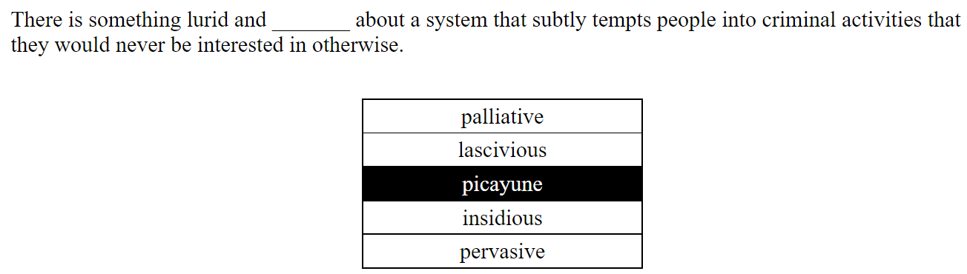

一个巧妙地诱使人们从事犯罪活动的系统有一些淫秽和_______，否则他们绝不会对这些活动感兴趣。

缓和的 palliative

淫荡的 好色的 lascivious

短暂的 picayune

隐秘的 阴险的 insidious 选这个

普遍的 pervasive

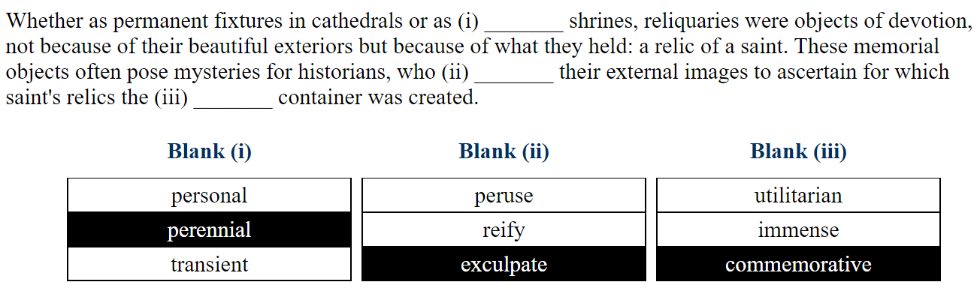

无论是作为大教堂的永久装置，还是作为(i) _______ 神龛，圣物箱都是虔诚的对象，不是因为它们美丽的外表，而是因为它们容纳的东西：圣人的遗物。这些纪念物常常给历史学家带来谜团，他们(ii) _______ 其外部形象，以确定(iii) _______ 容器是为哪位圣人的遗物而设。

空白(i)

个人

常年的 perennial

暂时性的 transient

空白(ii)

阅览 精读 peruse

证实 reify

开脱罪责 exculpate

空白(三)

功利的 utilitarian

巨大的 immense

纪念性 commemorative

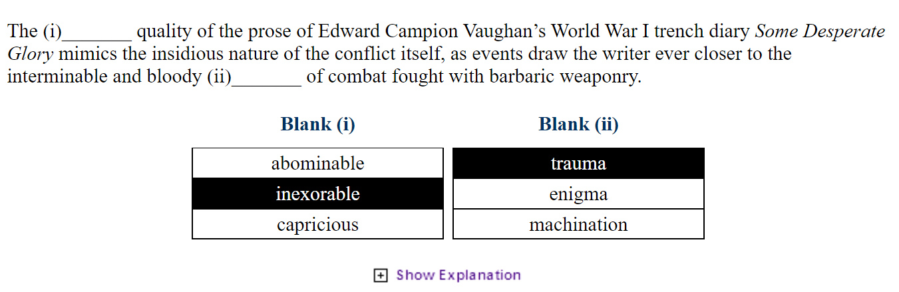

Prose 散文, Trench 沟壑 战壕, mimics 模仿, insidious 阴险的, enigma 谜团, machination 机关 阴谋诡计

Abominable 可憎的, inexorable 无情的 capricious 任性的

Newsworthy 有新闻价值的 deleterious 有害的

Innocuous 无辜的 meddlesome 多管闲事

Pernicious 恶毒的 manipulative 操纵性

Disinterested 无私的

Meddlesome 多管闲事

Affection for 感情方面

mistrust of 不信任

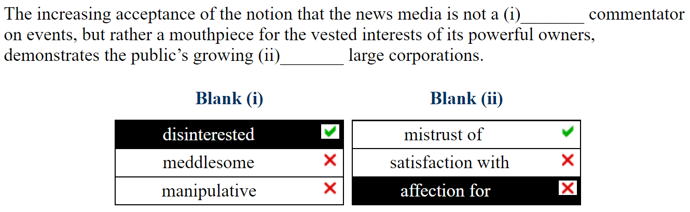

The increasing acceptance of the notion(观点) that the news media is not a disinterest(无私的) commentator(评论者) on events, but rather a mouthpiece(喉舌) for the vested interests(既得利益) of its powerful owners, demonstrates the public’s growing mistrust of large corporations.

越来越多的人接受这样的观点：新闻媒体不是事件的无私评论者，而是其强大所有者既得利益的喉舌，这表明公众对大公司越来越不信任。

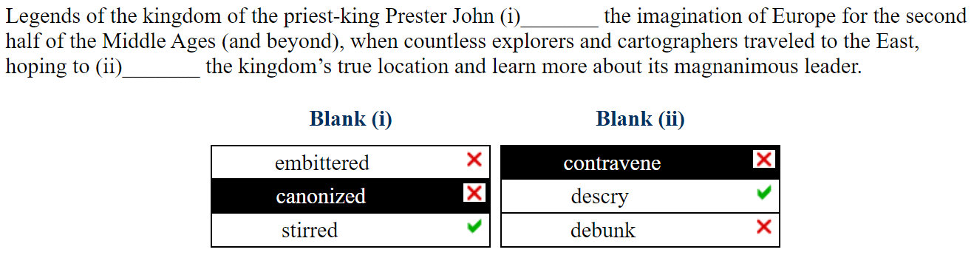

关于牧师王普雷斯特-约翰王国的传说在中世纪后半期（及以后）激起了欧洲人的想象力，当时无数的探险家和制图师前往东方，希望能找到这个王国的真实位置并了解其宽宏大量的领导人。

Embittered 愤世嫉俗 canonized 被封为圣人 Stirred 激动的 Contravene 违反 descry 描述 debunk 驳斥

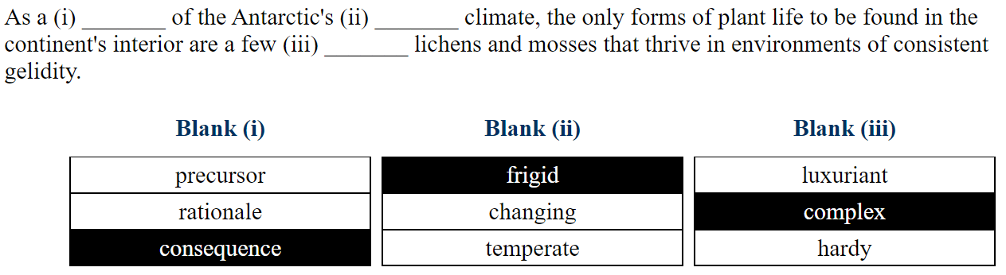

Precursor 前身 前奏 frigid 寒冷的 luxuriant 繁茂的

Rationale 理论依据

Consequence 后果 temperate 温带 hardy 坚韧

Lichens苔藓 mosses 地衣 gelidity 凝胶 环境

As a consequence of the Antarctic's frigid climate, the only forms of plant life to be found in the continent's interior are a few hardy lichens and mosses that thrive in environments of consistent gelidity.

由于南极寒冷的气候，在大陆内部发现的唯一植物生命形式是一些耐寒的地衣和苔藓，它们在稳定的环境中茁壮成长。

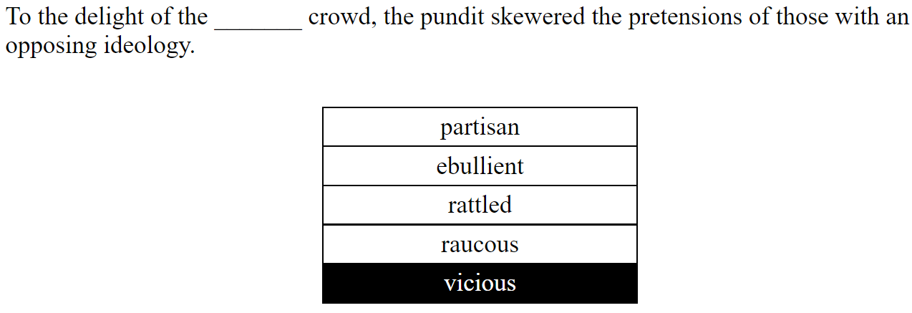

Delight 喜悦 pundit 专家 skewered 讽刺 rattled 哗然 vicious 恶毒的

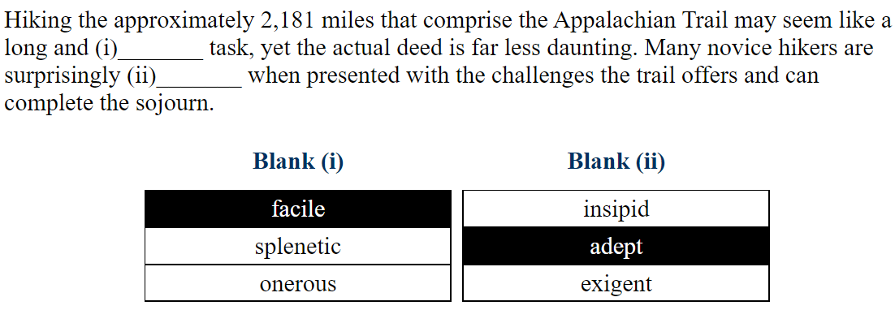

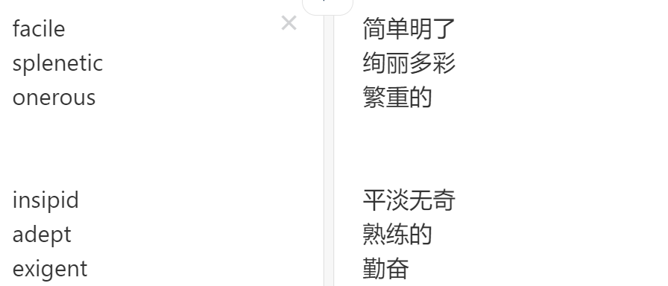

Despite the (i) _______ nature of many animals in myths as both creator and destroyer, bears were almost always connected with the feminine creative force because their (ii) _______ death each winter during hibernation, followed by their awakening in the spring, makes them symbols of nature’s capacity for annual (iii) _______.

|  |  |  |  |  |  |  |  |  |  |  |  |  |  |  |  |  |  |  |  |  |  |  |  |
| --- | --- | --- | --- | --- | --- | --- | --- | --- | --- | --- | --- | --- | --- | --- | --- | --- | --- | --- | --- | --- | --- | --- | --- |
| |  | | --- | | **Blank (i)** | | |  | | --- | | dual | | | |  | | --- | | antagonistic | | | |  | | --- | | inchoate | | | |  | | --- | | **Blank (ii)** | | |  | | --- | | personified | | | |  | | --- | | legendary | | | |  | | --- | | metaphorical | | | |  | | --- | | **Blank (iii)** | | |  | | --- | | extinction | | | |  | | --- | | renewal | | | |  | | --- | | transformation | | |

Antagonistic 对立的 Personified 拟人化 extinction 灭亡

Inchoate 不确定的 legendary 传说的 renewal 更新

Metaphorical 比喻性 transformation 转化

选择 ACB

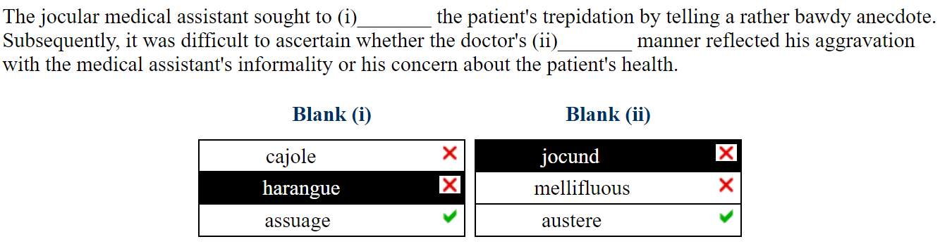

Jocular 诙谐 assuage

Cajole 劝说 jocund 劝说

Harangue 却说 mellifluous 口齿伶俐

Assuage 抚慰 austere 朴实

The jocular(诙谐) medical assistant sought to assuage(抚慰) the patient's trepidation(恐惧) by telling a rather bawdy(低俗) anecdote(轶闻). Subsequently, it was difficult to ascertain(确定) whether the doctor's austere(严厉的) manner reflected his aggravation with the medical assistant's informality or his concern about the patient's health.

幽默风趣的医疗助理试图通过讲述一个相当粗俗的轶事来缓解病人的恐惧心理。随后，很难确定医生的严厉态度是反映了他对医疗助理的非正式行为的不满，还是他对病人健康的担忧。

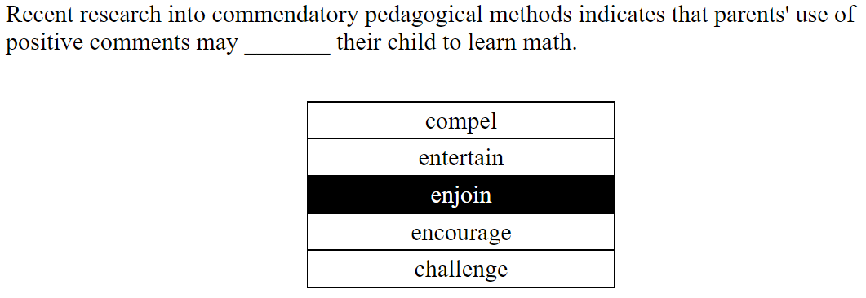

最近对表扬性(commendatory)教学法(pedagogical)的研究表明，父母使用积极的评论可能_______，让孩子学习数学。

Compel 迫使 entertain 招待 enjoin 嘱咐

选择encourage

The positive difference between the values of x at the x-intercepts of f(x)

f(x)的x截距处的x值(复数)之间的正差

In a recent survey, 80 percent of the people polled were registered voters, and 75 percent of the registered voters voted in the last election. What fraction of all those surveyed were registered voters who did not vote in the last election?

在最近的一项调查中，80%的受访者(people polled)是注册选民，75%的注册选民在上次选举中投票。在所有接受调查的人中，在上次选举中没有投票的登记选民占多大比例？

Polled 被调查的

A的数量是B的两倍。

There are twice as many A as B.

A bag of candy contains only nut chewies and marshmallow delights. There are twice as many nut chewies as marshmallow delights. The nut chewies are either peanut or cashew, and there are 13 as many cashew chewies as there are peanut chewies. If Julie selects one piece of candy at random, what is the probability that she picks a cashew chewy?

一袋糖果中只有坚果咀嚼片和棉花糖点心。坚果嚼片的数量是棉花糖的两倍。坚果嚼片不是花生就是腰果，腰果嚼片的数量是花生嚼片的13倍。如果朱莉随机选择一块糖果，她选到腰果嚼片的概率是多少？

答案是1/6

As the accomplished raconteur delved ever more deeply into his suspenseful tale, the rapt listeners fell silent, quivering on the edge of an excitement so expertly and carefully constructed, it was almost

palpable.

随着这位才华横溢的讲述者越来越深入地钻研他的悬疑故事，全神贯注的听众陷入了沉默，在如此专业和精心构建的兴奋边缘颤抖着，这几乎是触手可及。

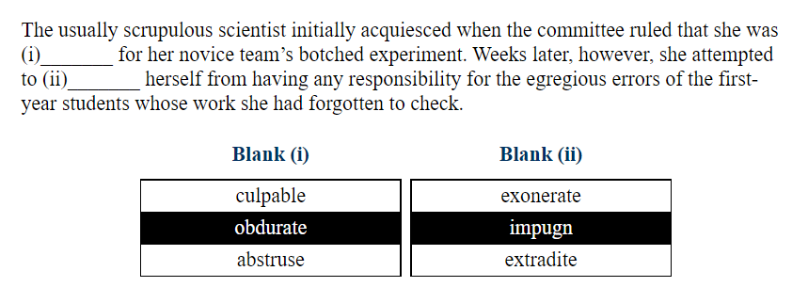

The usually scrupulous scientist initially acquiesced(默许了) when the committee ruled(裁定) that she was culpable(有罪的) for her novice team's botched(错误) experiment. Weeks later, however, she attempted to exonerate(开脱) herself from having any responsibility for the egregious(严重的) errors of the first year students whose work she had forgotten to check.

当委员会裁定她对她的新手团队的错误实验负有责任时，这位通常一丝不苟的科学家最初默许了。然而，几周后，她试图为自己开脱责任，因为她忘了检查一年级学生的工作，而这些学生犯了严重的错误。

Acquiesced 默许了 culpable 有罪的 obdurate 顽固的Abstruse 深奥的 exonerate 开脱责任 impugn 谴责 extradite 引渡

Malign 恶毒 erudite 博学 frivolous 无聊的 abase 贬低 venerate 尊敬的 expatiate 夸大其词

Quadrupeds 四足动物 bipedal 双足动物 pragmatic 实事求是 verbose 啰嗦的 categorical 绝对的

Dispassionate 冷静的

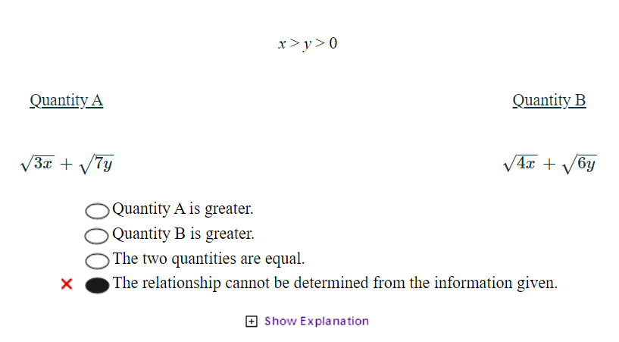

平方A B 再比较

选择A

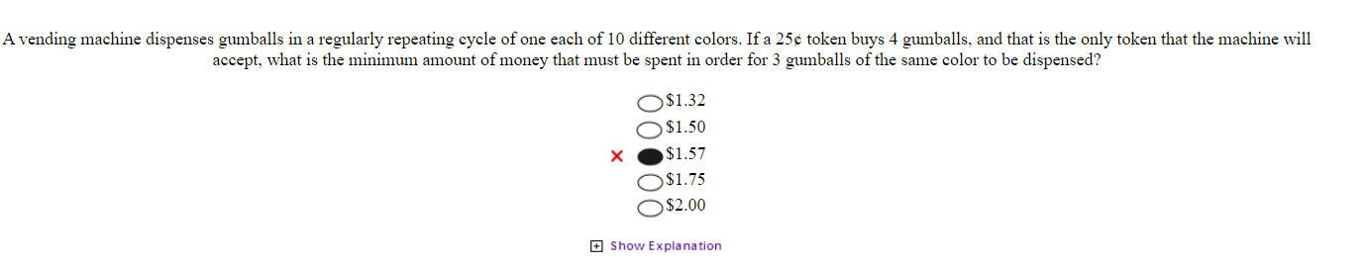

25美分买的是4个而不是5个。

选B

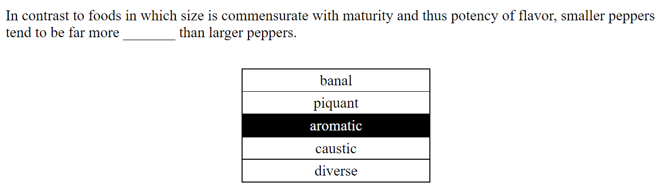

In contrast to foods in which size is commensurate with maturity and thus potency of flavor, smaller peppers tend to be far more _______ than larger peppers.

banal

piquant

aromatic

caustic

diverse

与食物的大小与成熟度相称，从而与味道的效力相称的情况相反，小辣椒往往比大辣椒更_______。

平淡

辣味

芳香的

腐蚀性的

多种多样

选择 piquant

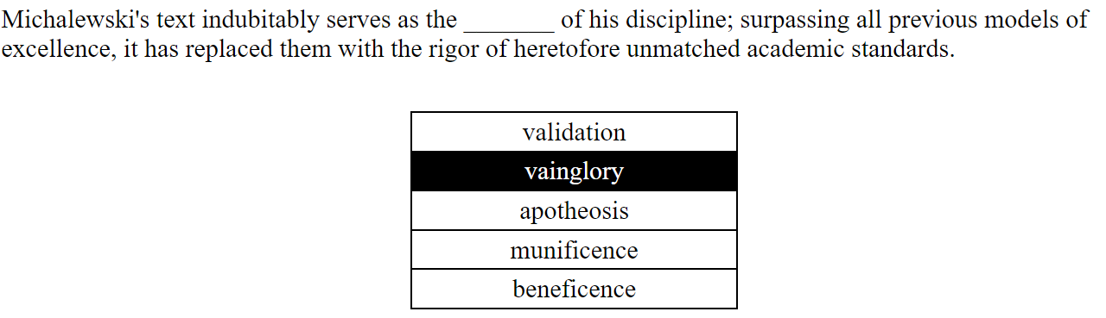

Michalewski's text indubitably serves as the _______ of his discipline; surpassing all previous models of excellence, it has replaced them with the rigor of heretofore unmatched academic standards.

validation

vainglory

apotheosis

munificence

beneficence

米哈列夫斯基的文本无可争议地成为其学科的_______；它超越了以前所有的优秀模式，以前所未有的严格的学术标准取代了它们。

验证

虚荣心

神化

仁慈

恩惠

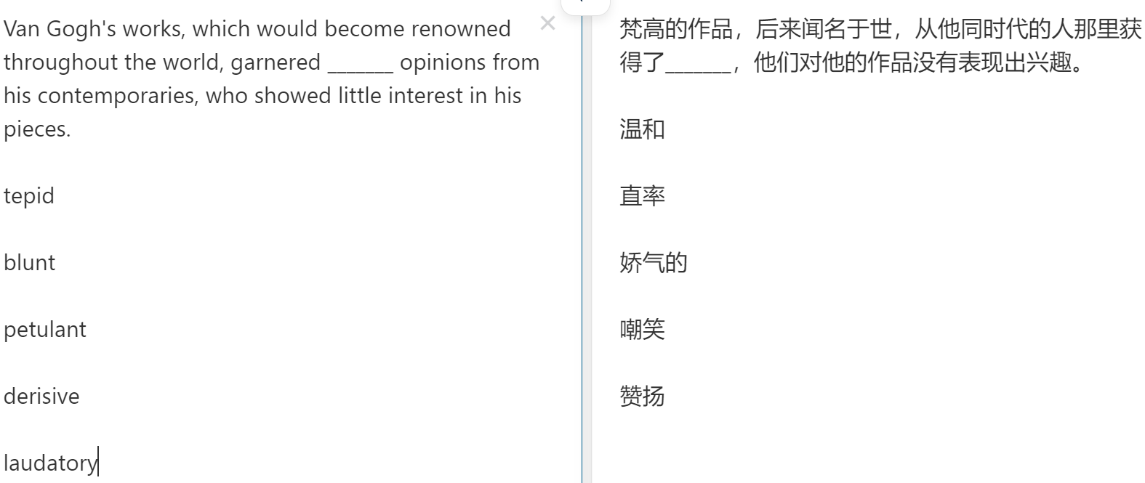

选择 A

改错到Ken20 第五题

Vagaries 变化无常

09点03分 2021年11月1日星期一

Critics have traditionally associated(联系起来) Guy de Maupassant with the irony displayed in his celebrated stories “The Necklace” and “The Piece of String.” While Maupassant does indeed indulge his taste for the unexpected in these two pieces, the “surprise” endings are not meant simply as gimmickry(噱头) to tickle the reader(逗读者), as has often been asserted, but rather as devices to highlight the injustices of life. In fact, in the bulk of his oeuvre, Maupassant is more concerned with exploring the vagaries(变化无常 变幻莫测) of fate than with merely entertaining his public.

In “Miss Harriet,” for example, Maupassant’s narrator reminisces(回忆) about an odd woman whose sudden death prompts in him feelings of both pity and passion(怜悯和激情). Yet the death itself, dramatic as it is, does not serve primarily to shock. Instead, Maupassant uses the woman’s demise(逝去) to underscore the discrepancy(差别 差异) between appearance and actuality and, more importantly, to emphasize the frequent cruelty of fate. In life, Miss Harriet, the doomed title character, seems to the narrator dry and single-minded, devoid of any human heat. In death, however, Miss Harriet suddenly becomes a “true” woman in the narrator’s eyes, a woman whose feelings for the narrator simmered(煨 熬 拼命忍住) quietly beneath her reserve. The narrator only then realizes the strength of this own attraction to her. Now that is too late.

Refute 反驳

Oeuvres 作品

The audience member claimed not to have been (i)_______ by the comedian's inappropriate(不当) remarks(言论), but her ramrod posture and (ii)_______ eyes, captured on multiple cameras, hinted(暗示) at her barely suppressed displeasure.

charmed

affronted

castigated

glowering

demure

sentimental

观众声称没有 (i)_______ 喜剧演员的不当言论，但她的推杆姿势和 (ii)_______ 眼睛被多台摄像机捕捉到，暗示了她几乎无法抑制的不满。

迷住了

冒犯 affronted

严厉的 castigated

忧郁 glowering

端庄 demure

感伤的 sentimental

选择BD

Concession 优惠 让步

Anachronism 不合时宜

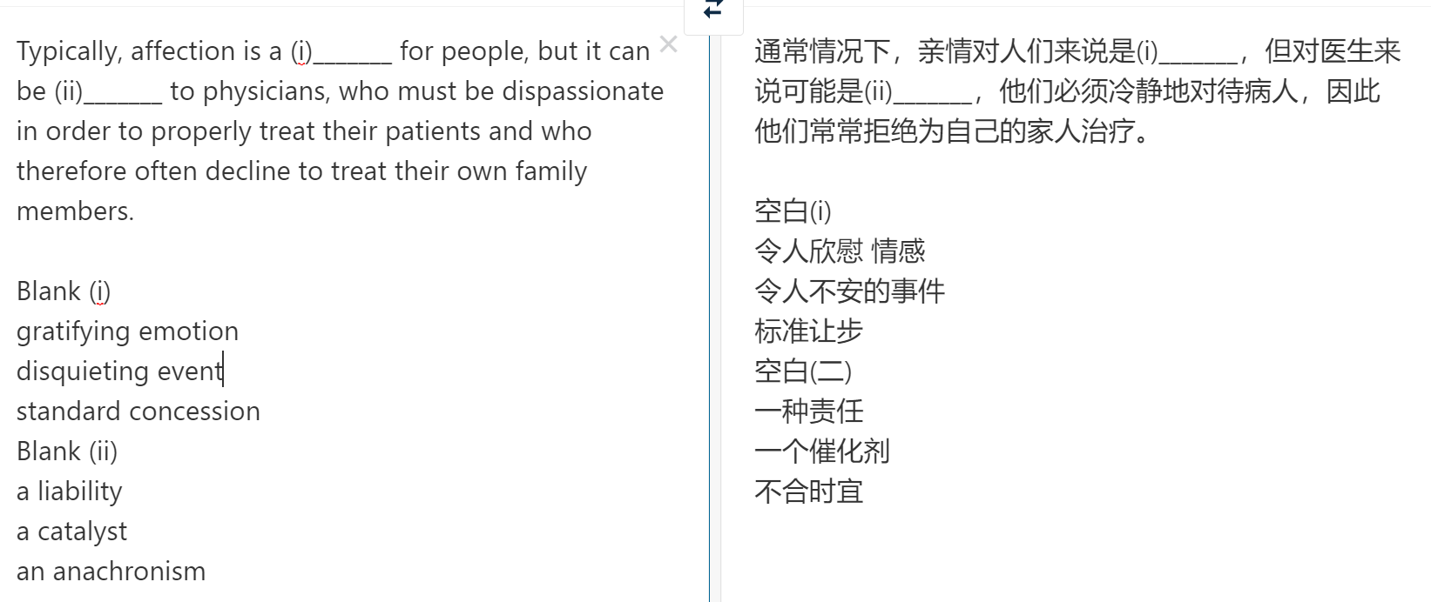

选择 gratifying emotion, a liability

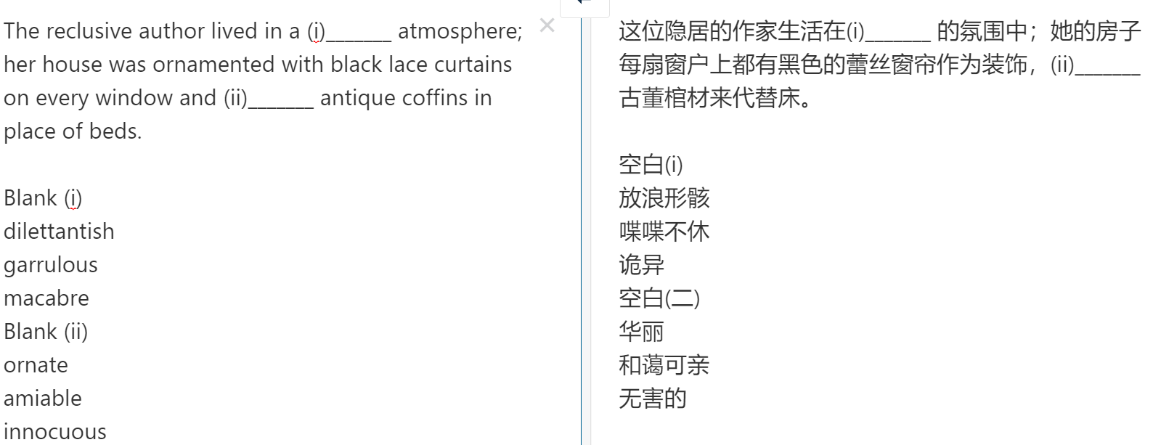

Coffins 棺材

//

Oxalate 草酸

dietary calcium 膳食中的钙

misinterpret 误解

Pulchritude 精益求精

Psyche 精神

Comeliness 风度翩翩

Acclamation 故障

Homeliness 朴实无华

Charisma 魅力

Immortalized 永生

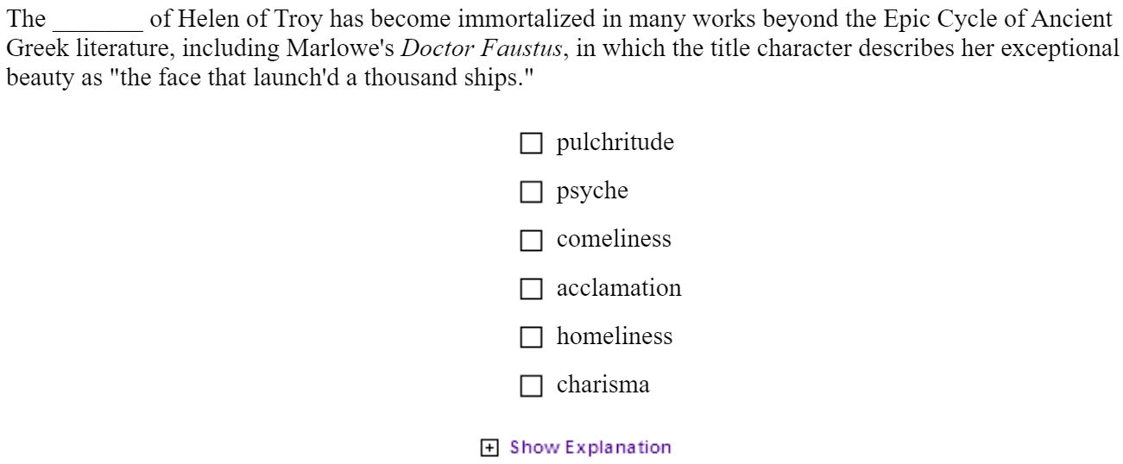

Accolades 荣誉

Retributions 报应

Supplications 恳求

Amendments 修正

Rectifications 整改

Gaffes 失态

Luminary 发光体

Confidant 知己

Archrival 死敌

Fabricated 捏造的

sincere真诚

punitive 惩罚性的

disparage 贬损

castigate 鞭挞

obviate 避免

eulogize讴歌

espouse配偶

ameliorate改善

prevailing 盛行

quantum量子

unknown未知

doctored篡改

irrefutable无可辩驳的

irreducible不可约的

Patterns of starts were committed to memory as the shapes of darting parrotfish or elaborate triggerfish.

开始的模式作为飞镖的鹦嘴鱼或精心制作的引金鱼的形状被记忆。

poetry 诗歌

verses 诗句

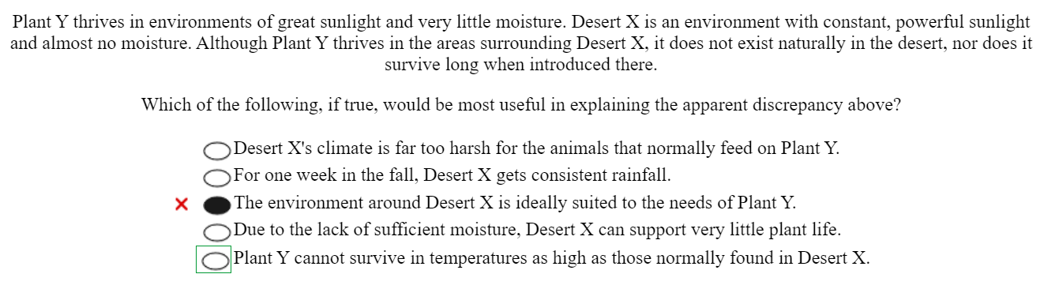

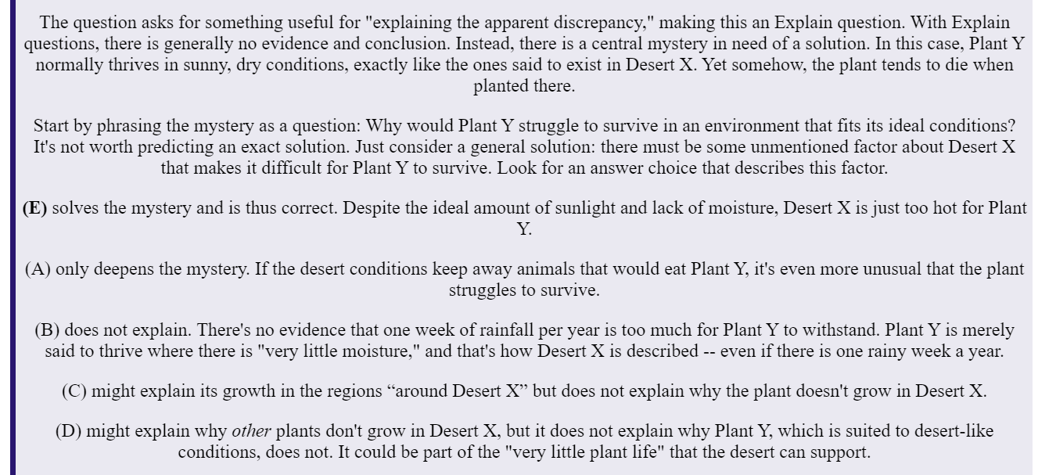

TAKEAWAY: For Explain questions, paraphrase the central mystery as a question and look for the answer that solves that mystery.